**Introduction-Case Study**Kathmandu College is the newly opened College of Science and Technology in Kathmandu, Bafal. This college has a Student,staff,Teacher,Library and Sport Department.Numbers of student,teacher,staff,Sport items and book items are present there.  
  
**Problem Statement:**This college is newly opened so it needs the database system to keep the record of financial transactions.

**Requirements**This college requires a solution that would enable them to add Student,Teacher and staff.As well as college can open their account and keep the record of transactions. The solution must have the following requirements:

i. Student : The solution must allow add student’s Information in system .

ii. Teacher:The solution must allow add teacher’s Information in system

iii.Staff :The solution must allow add Staff’s Information in system

iv.Account : The solution must allow to add salaries for student and fee for   
 student.Likewise, maintain the record of the salary withdraw

and fee pay for student respectively.

v .Sports Item: The Solution must allow to add sport items in system and keep  
 record of return and issued.

vi.BookItem: The solution must allow adding books in the system.

vii. Fine Amount:The solution must allow add fine in the system.

**Solution**To meet the requirements of Kathmandu College ,we propose a system with the following features:  
  
1 .Student Table: The system will allow to students and their information in the

system

2. Staff Table :The system will allow to Staffs and their information in the

system.

3. Teacher Table : The system will allow to Teacher and their information in the

system

4 Student Account Table :The system will allow to record fee that student pay as well as

remaining fee,and date when student pay  
   
  
5 Teacher Account Table: The system will record the salary of individuals teacher along   
 With their salary credit and remaining salary.

6. Staff Account Table : The system will record the salary of individuals staff along   
 With their salary credit and remaining salary.

7 Book_items Table: The system will allow to record the books in the system

8 Sports_item Table: The system will allow to record the sport_items in the system  
  
   
9 Issued_and_return_item_Table:The system will allow to keep issued and return records  
 along with fine amount.

**Task One :UML Class Diagram**

UML class Diagram of CollegeDataBase

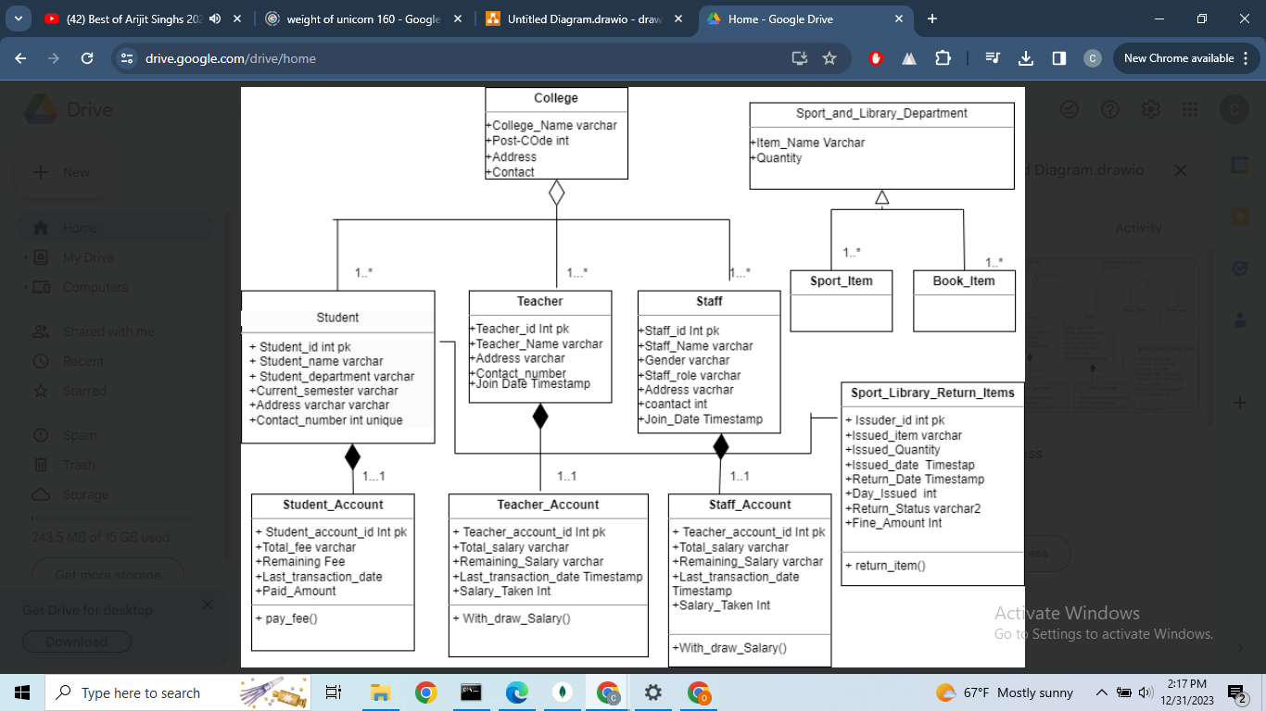

## Task Two:

### Demonstration of SQL Code and its working.

### a. Drop Tables and Sequence

Query:  
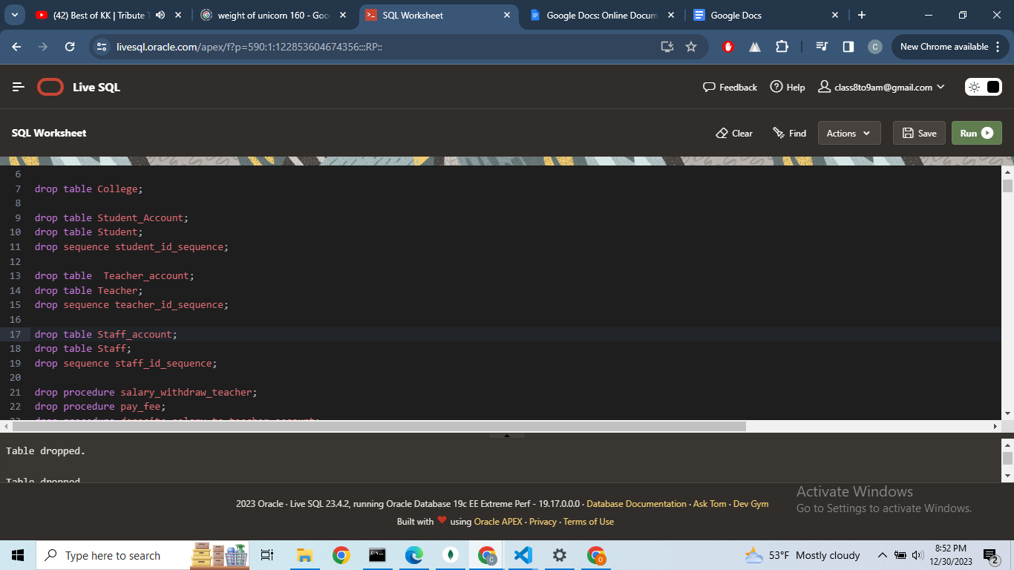  
  
Output  
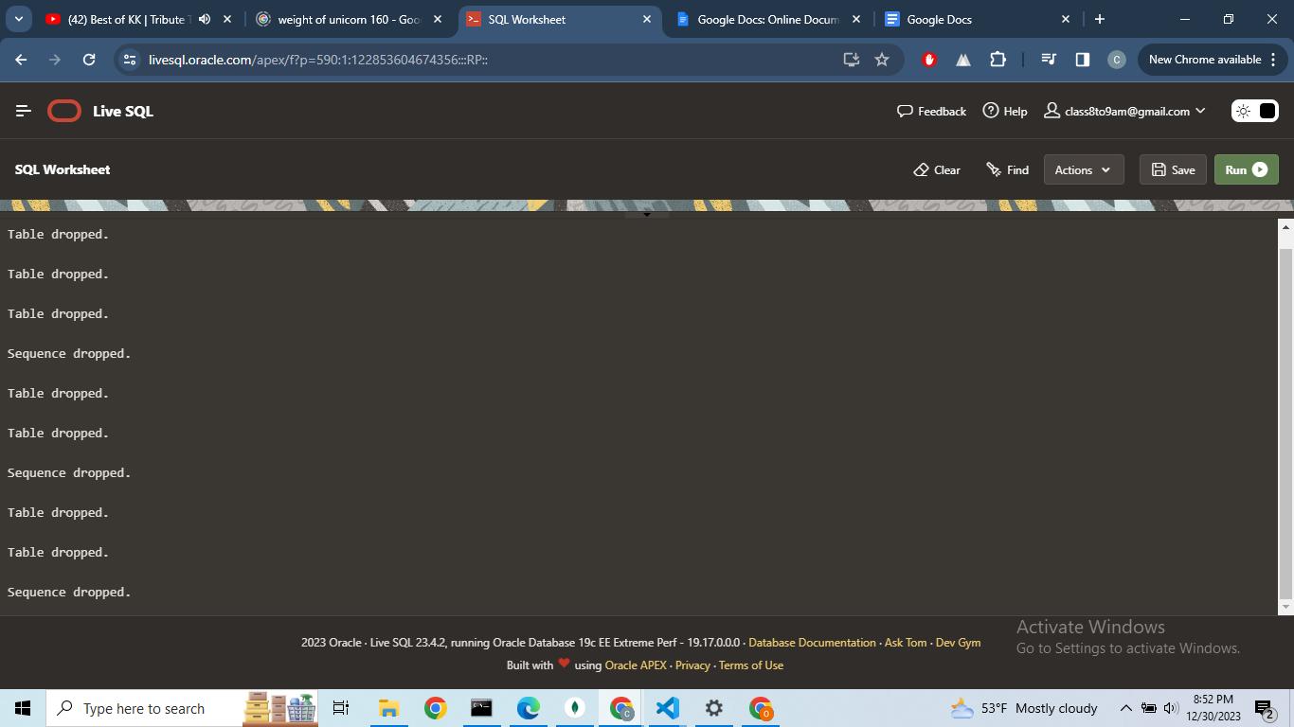

### **b. Drop Triggers**

**Query:**  
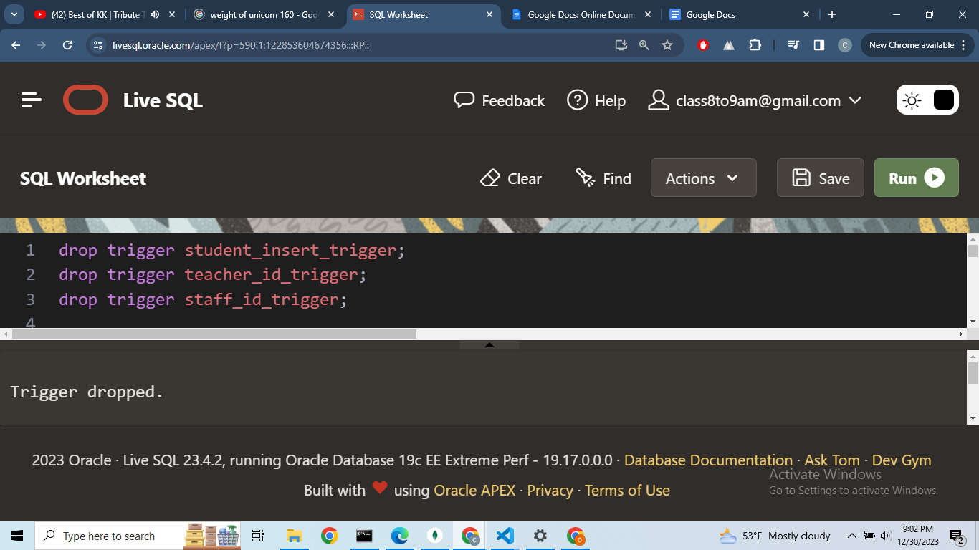

**Output  
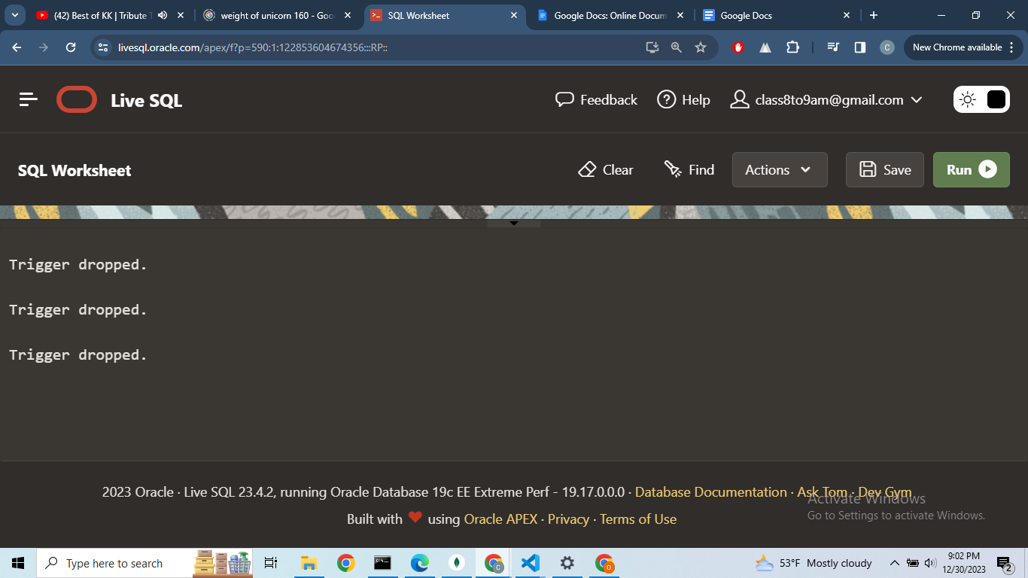**

### **c. Drop Procedure Query**

**Output:  
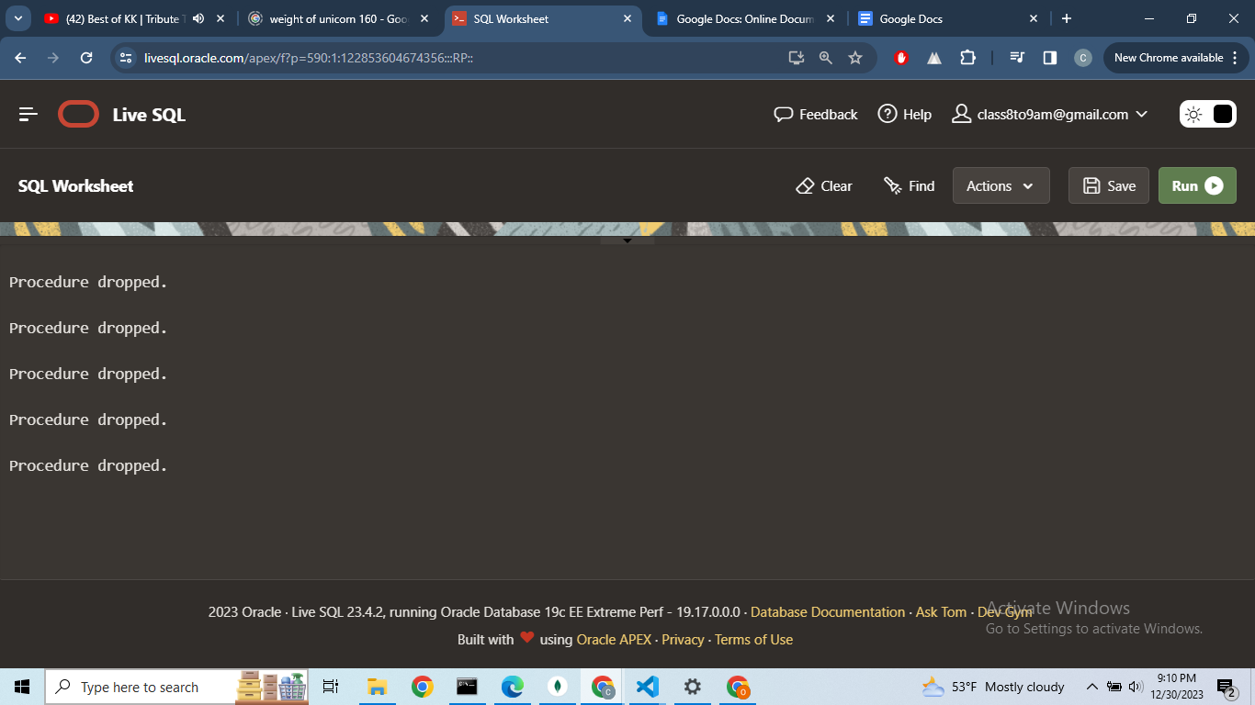**

**c.Drop Type and Table   
  
Query:  
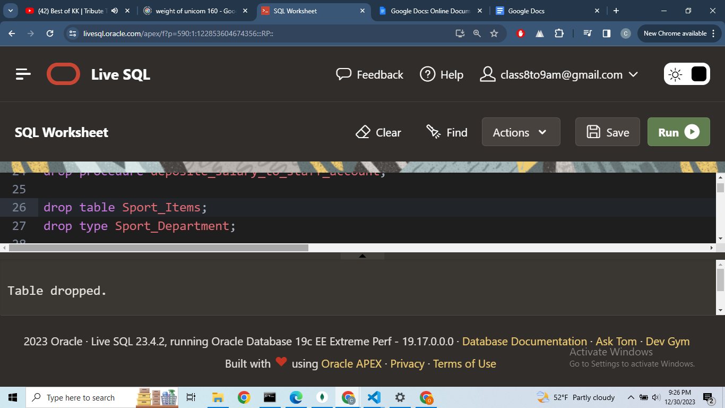**

**Output:  
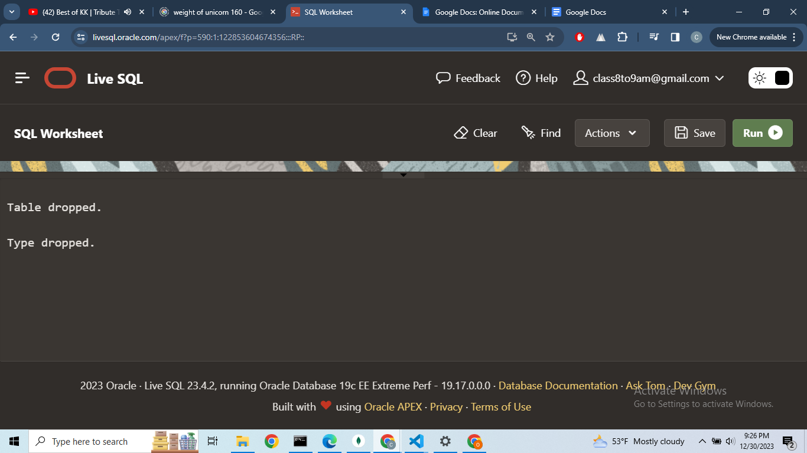  
  
Query:  
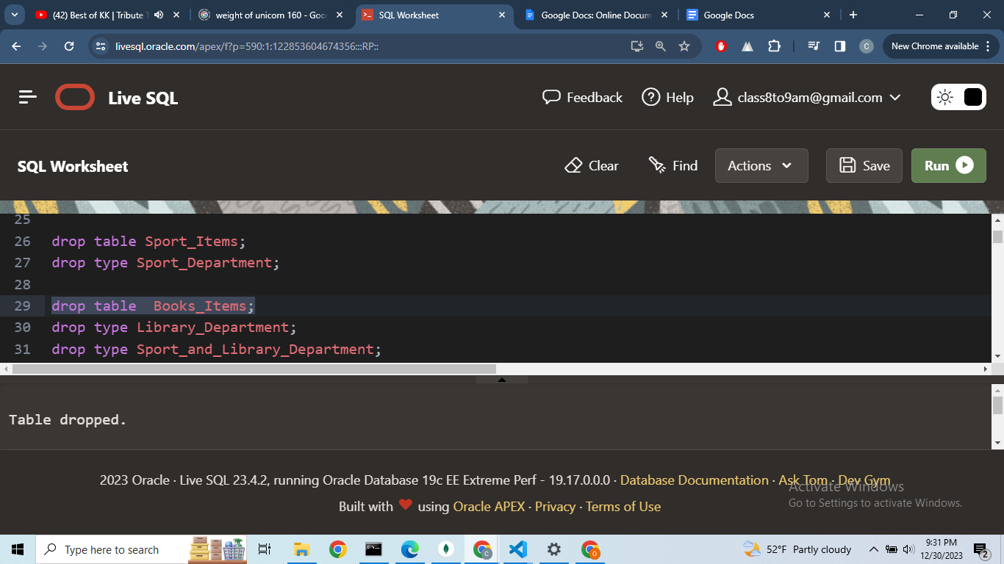  
Output:**

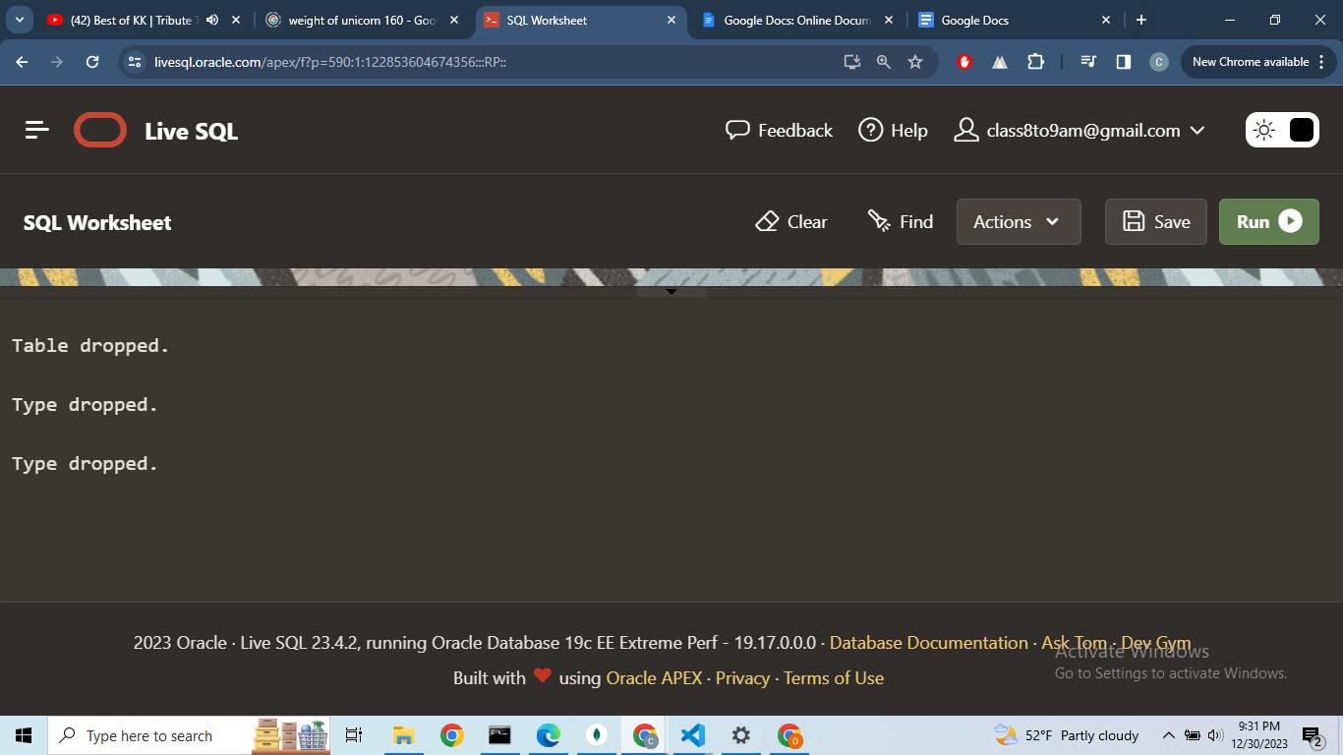

**Query:  
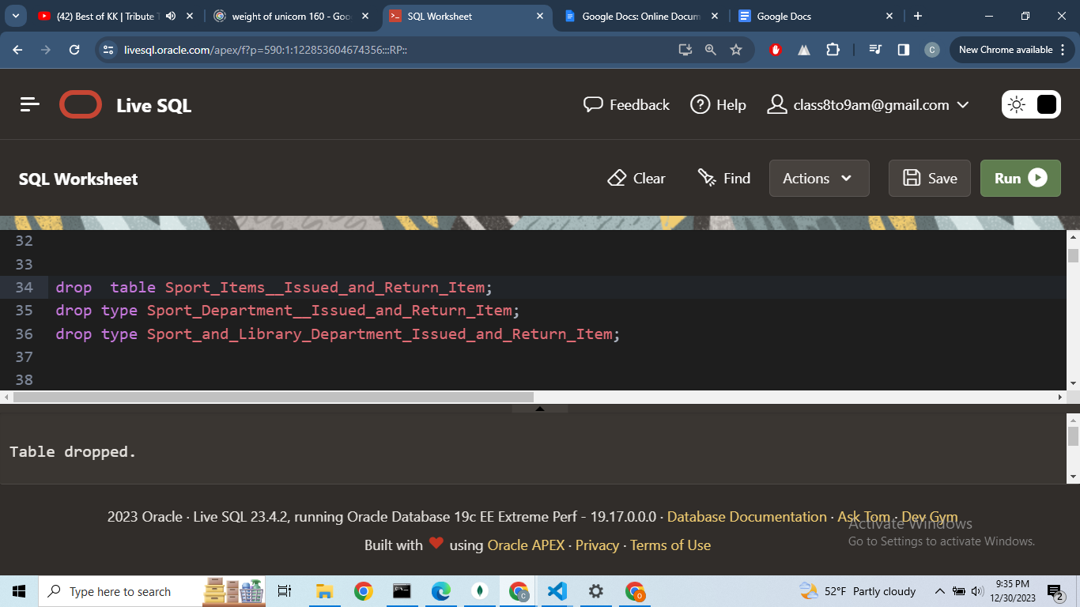**

**Output:  
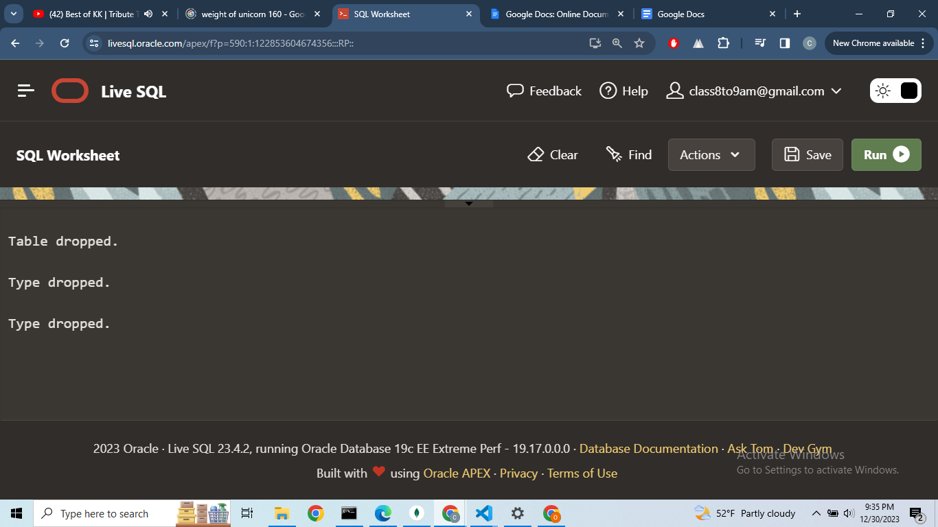**

**Creating Table, sequence,procedure and Trigger:  
Query:  
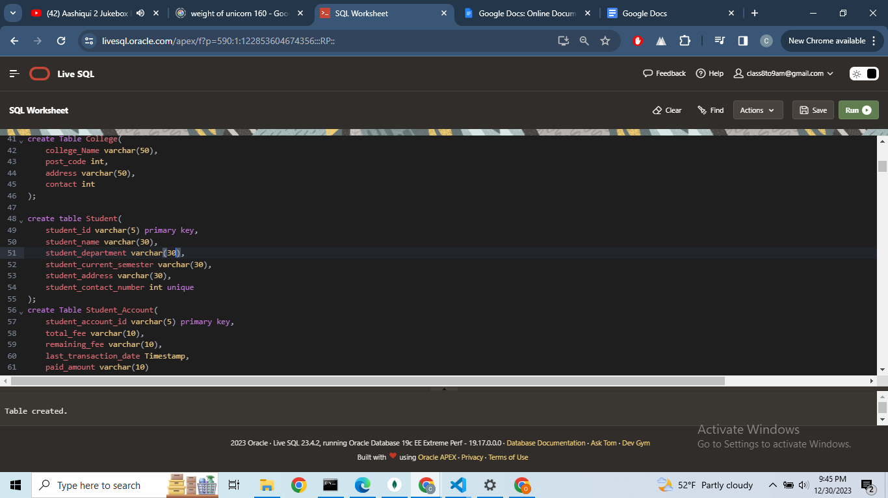**

**Output:  
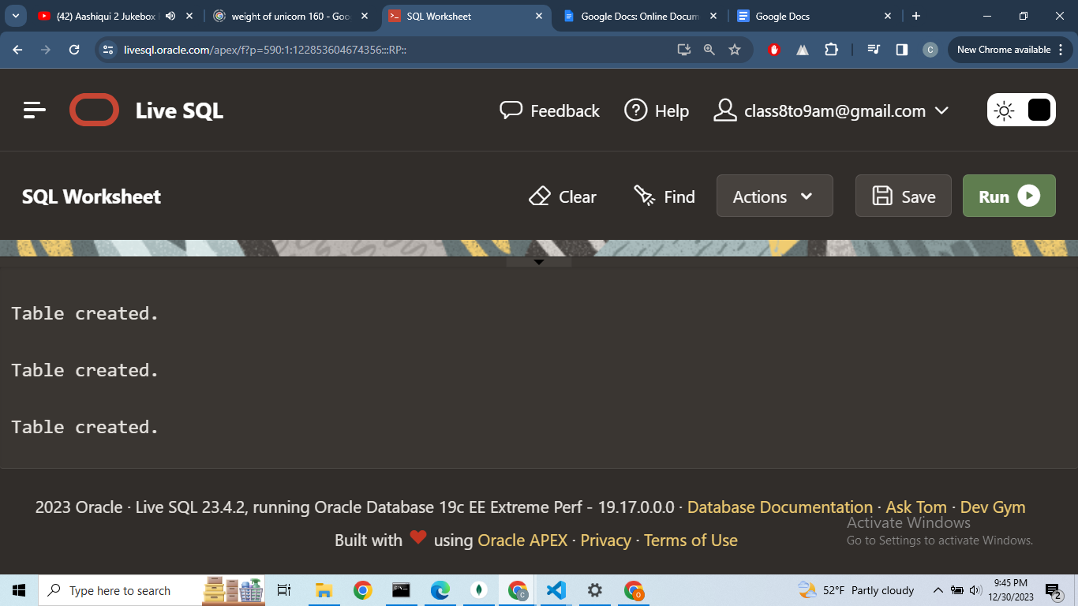**

**Query:  
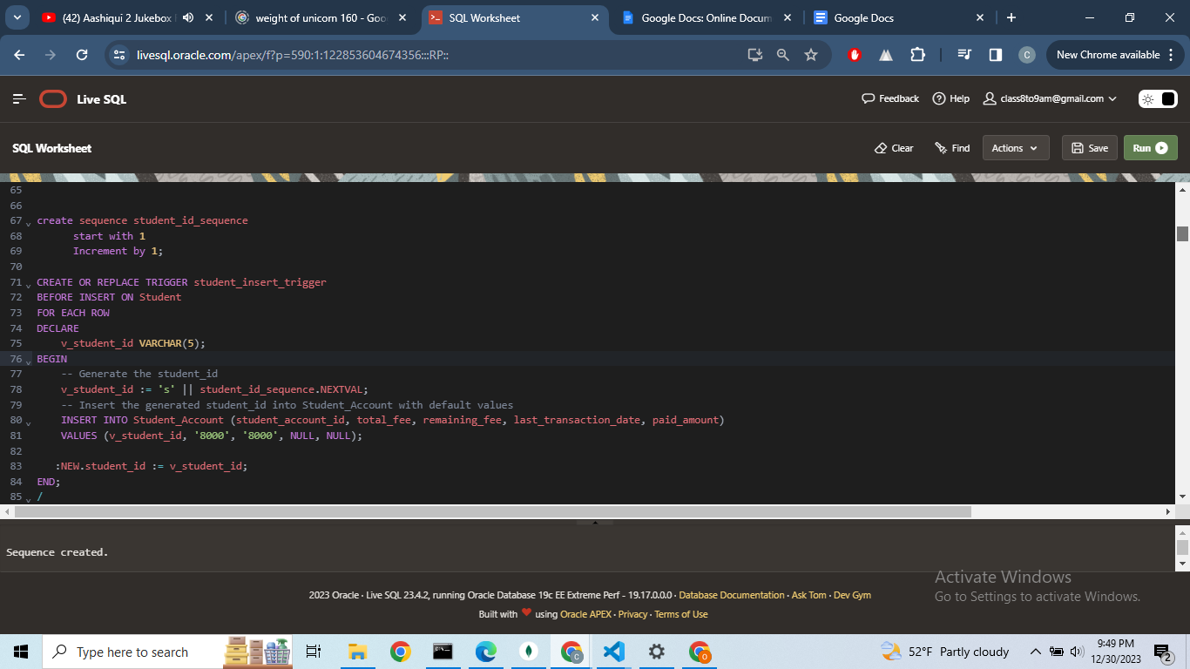  
  
Output:  
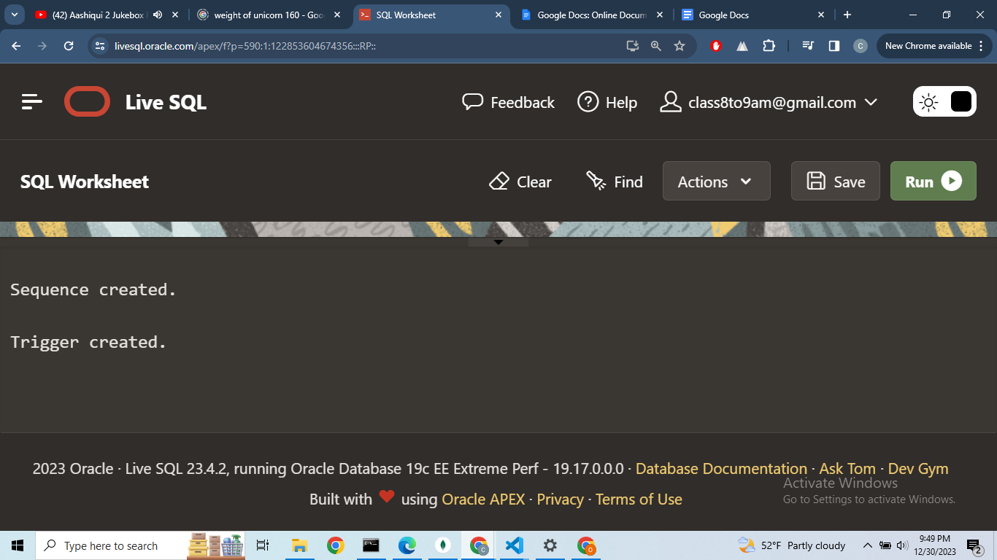**

**Query:  
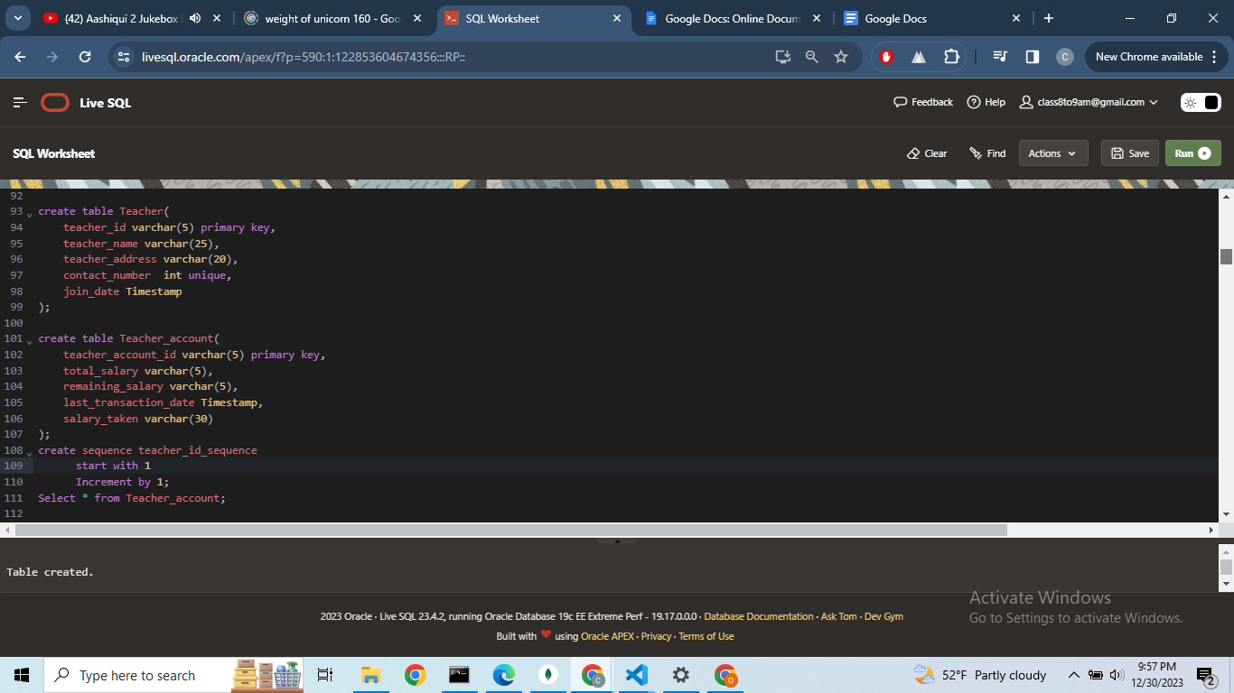**

**Output:**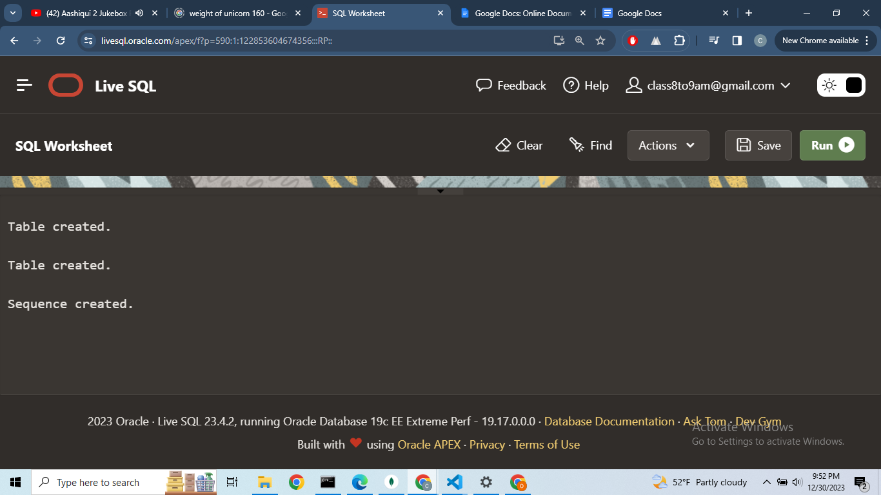

**Query:  
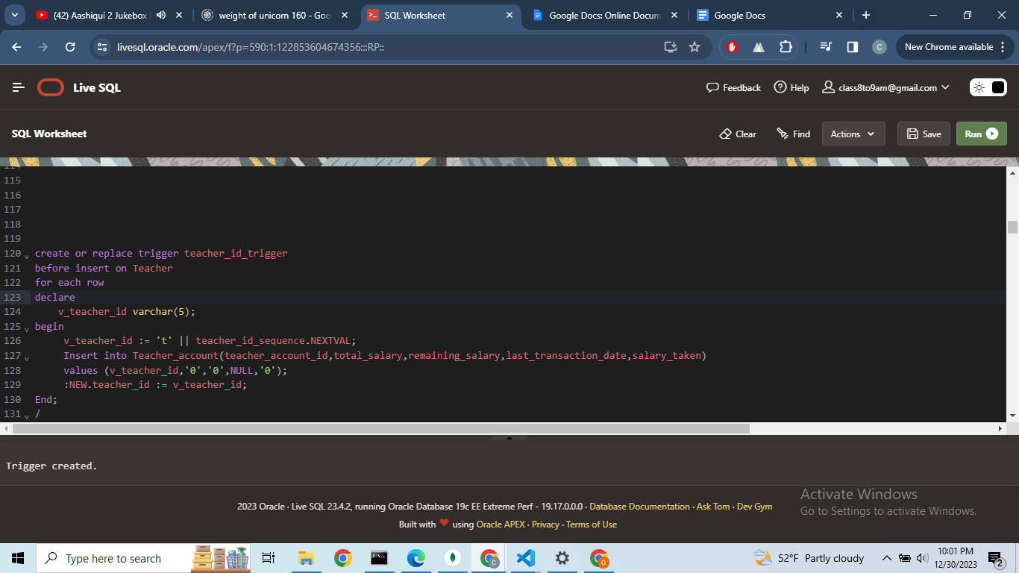**

**Output:  
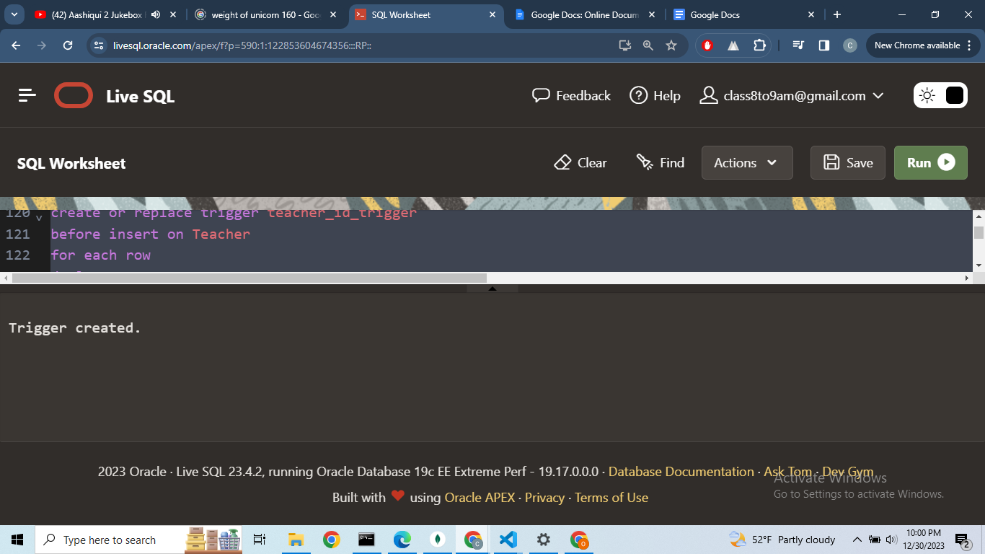**

**Query:  
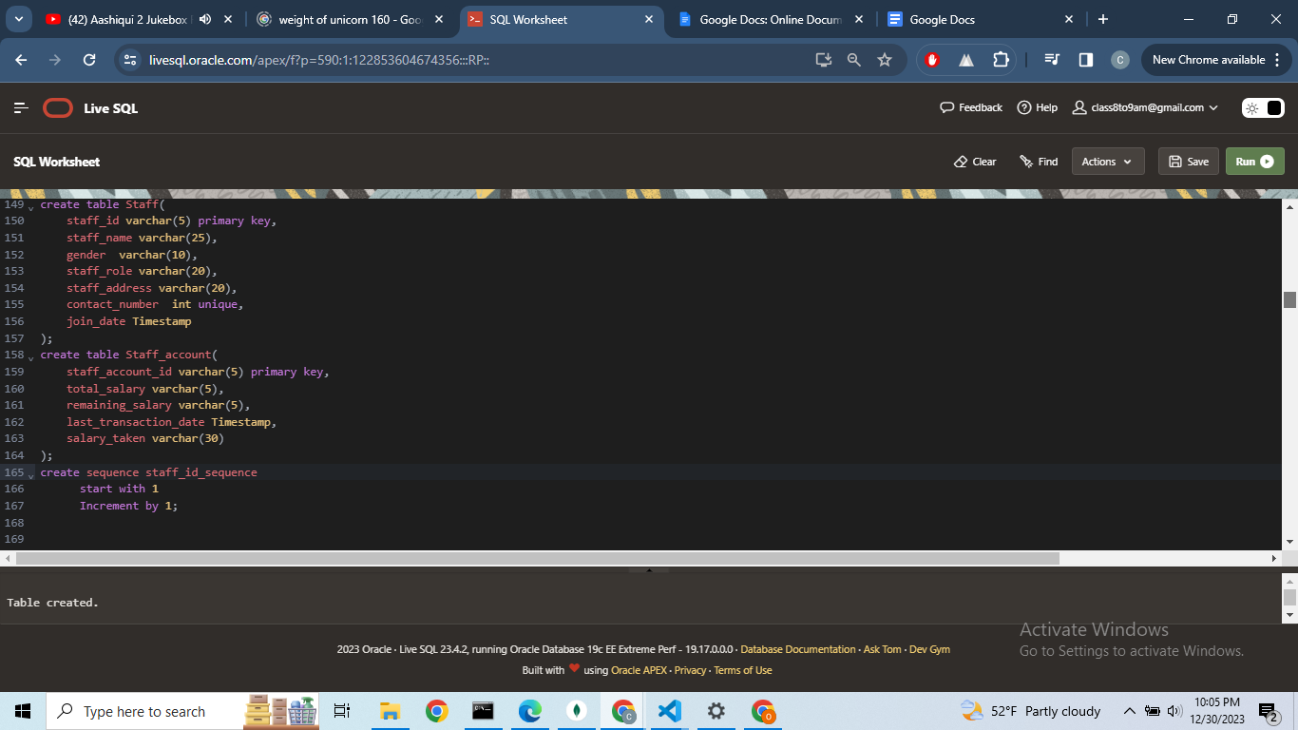  
  
  
Output:  
**

**Query:  
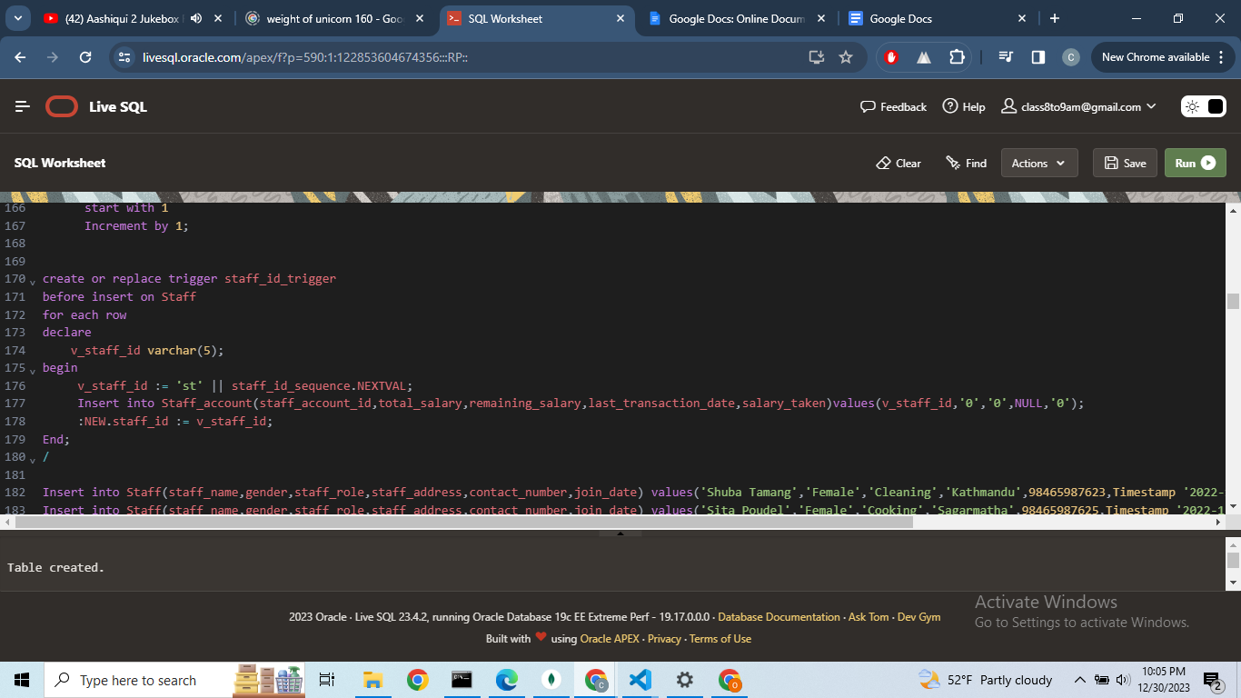**

**Output:  
**

**Query:  
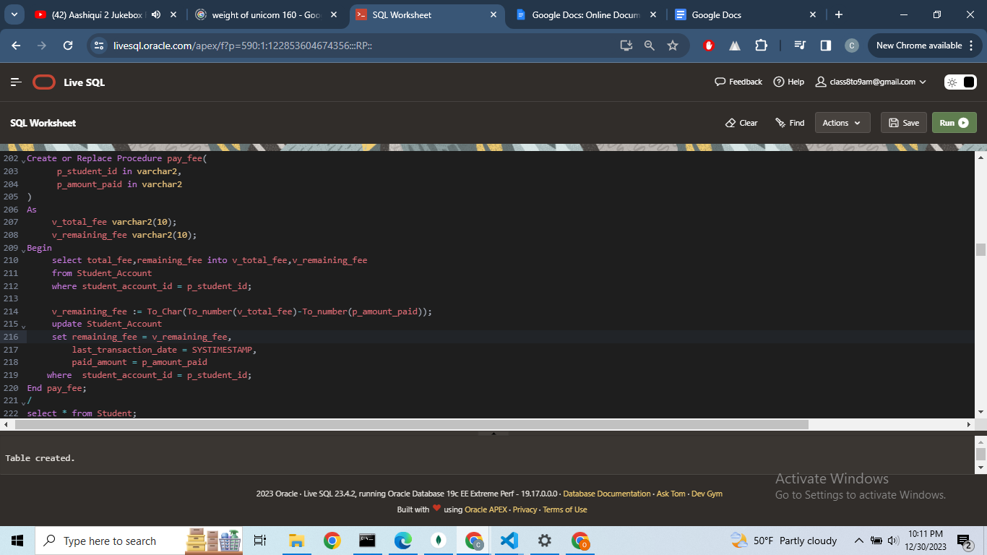**

**Output:  
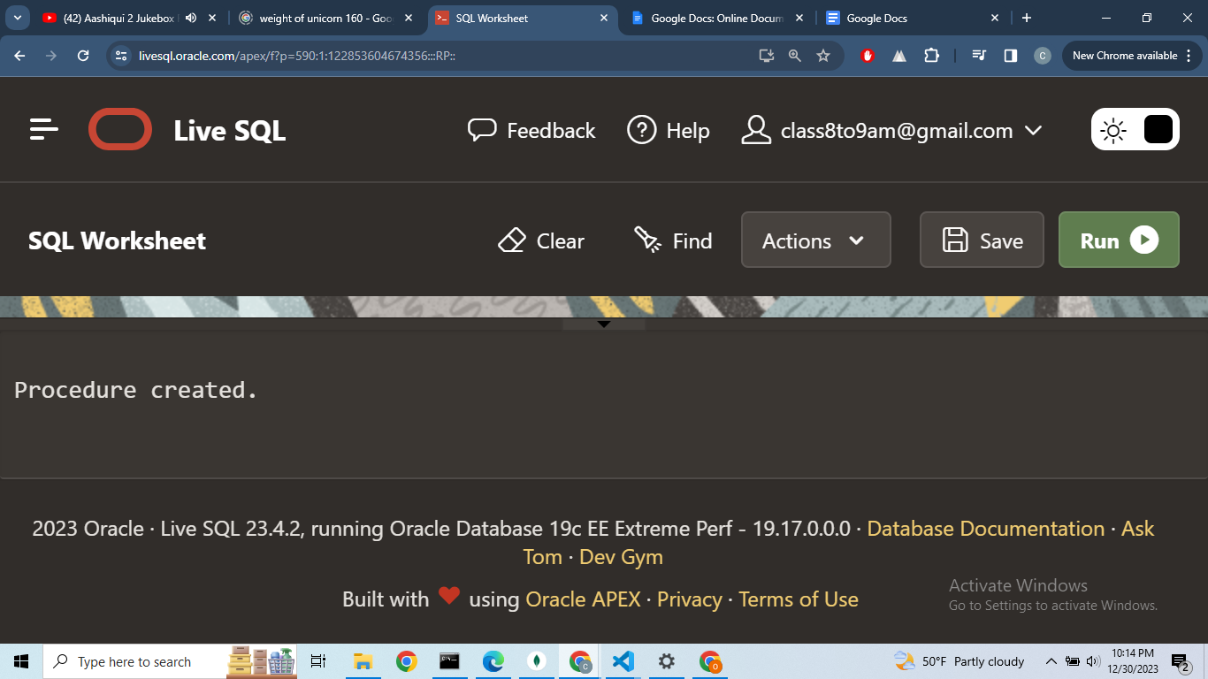  
  
  
  
  
Query:  
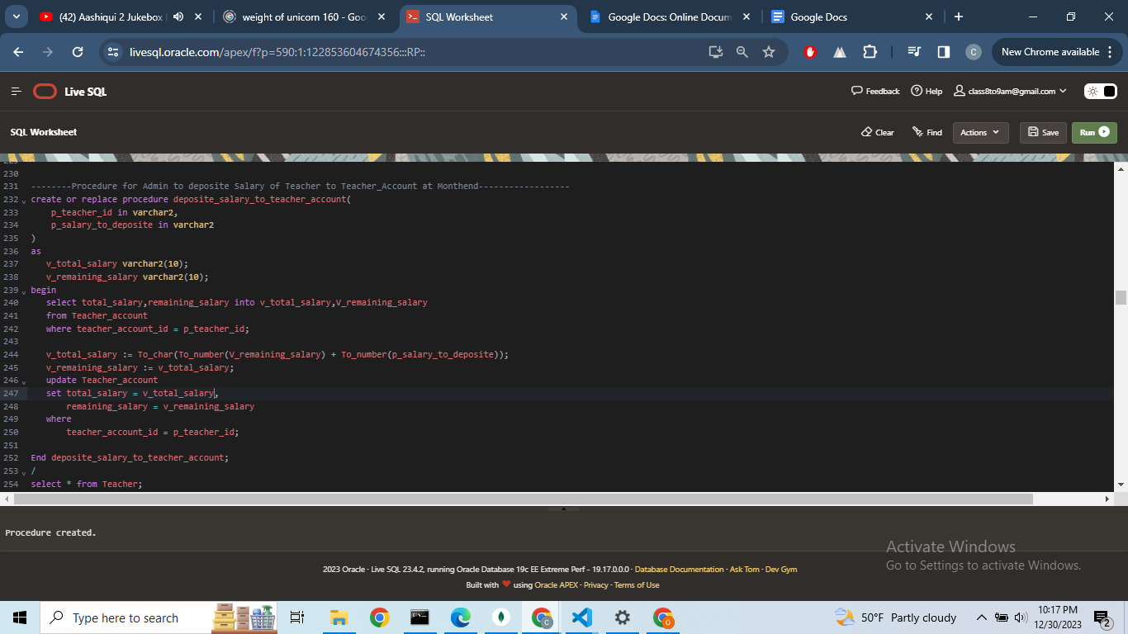  
  
  
  
Output:  
**

**Query:  
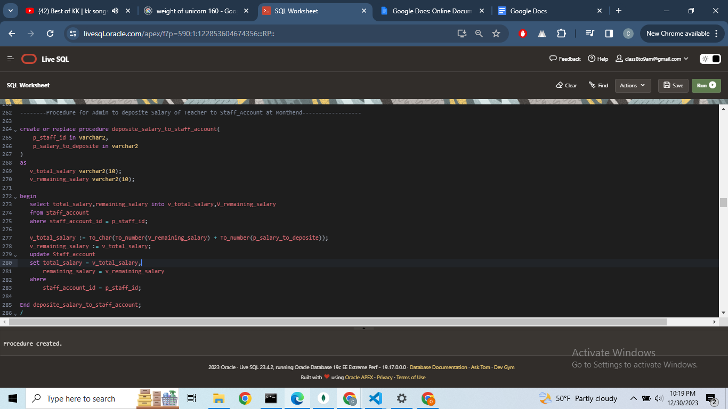  
  
  
  
  
Output:  
**

**Query:  
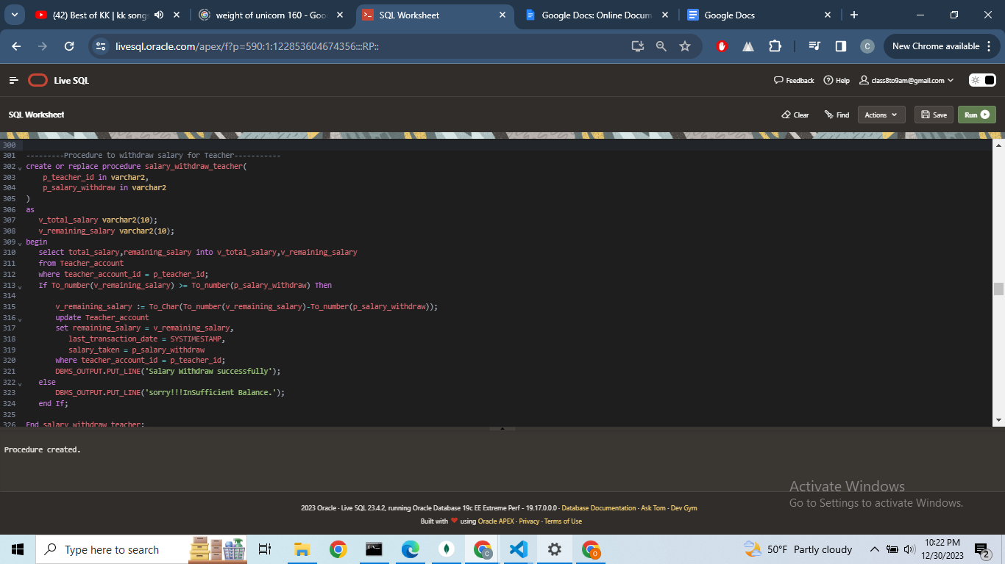**

**Output:  
**

**Query:  
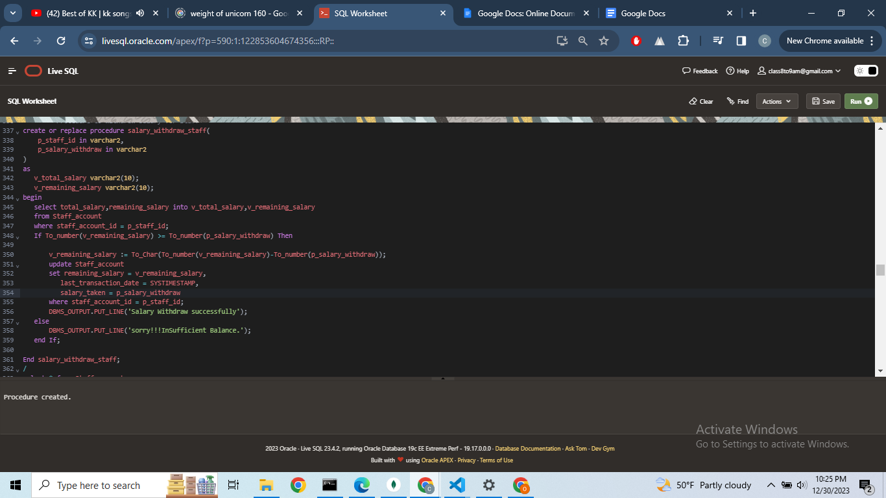  
  
  
  
Output:  
**

**Query:  
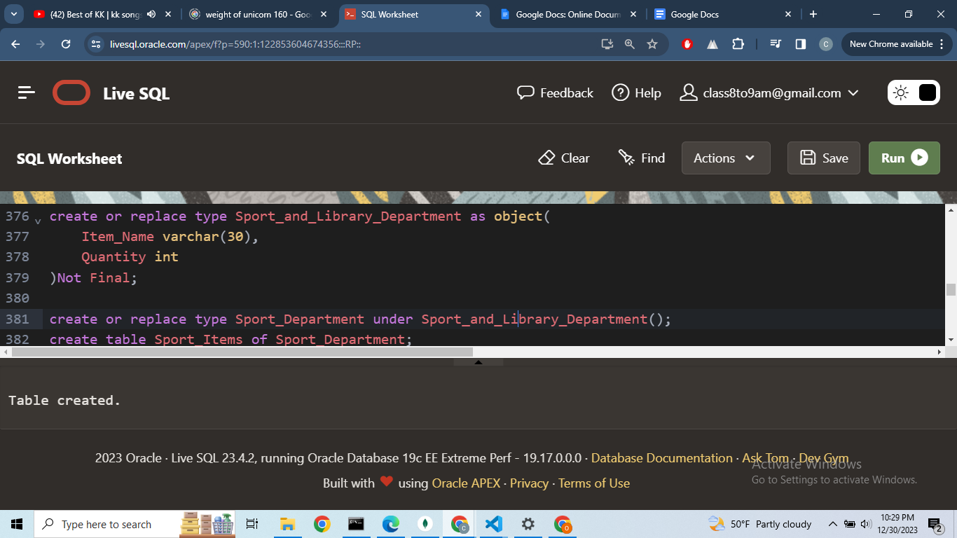  
  
  
Output:  
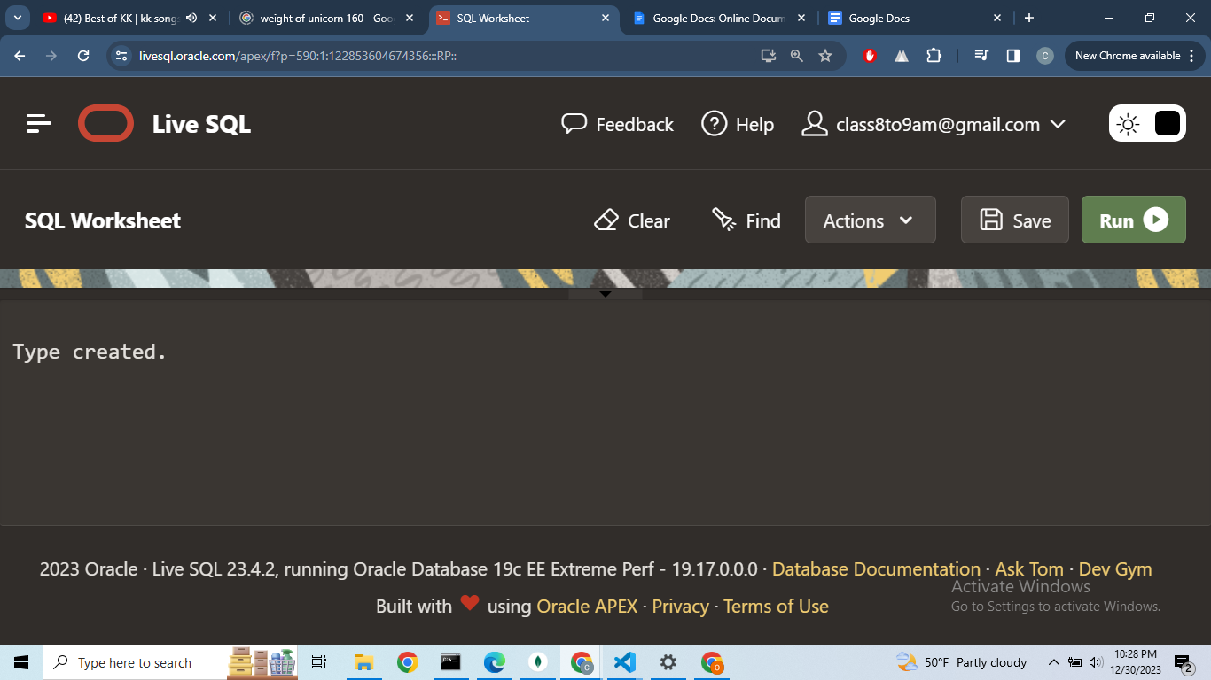**



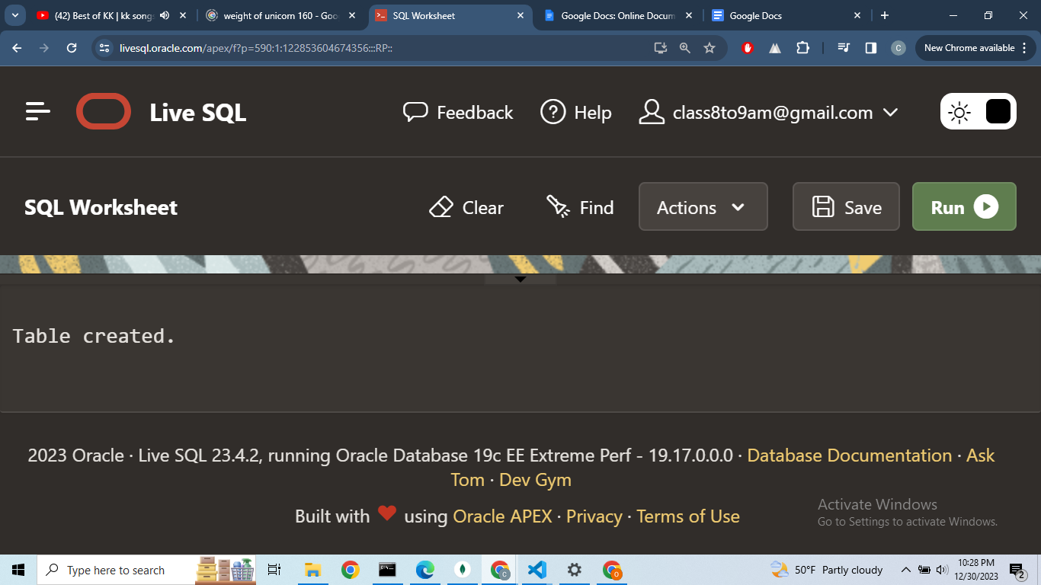

**Query:  
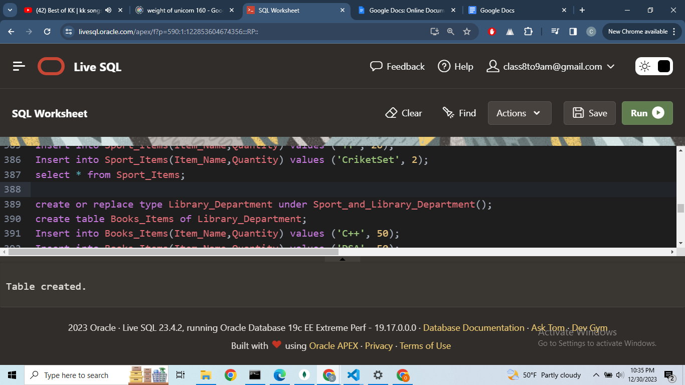**

**Output:  
**



**Query:**

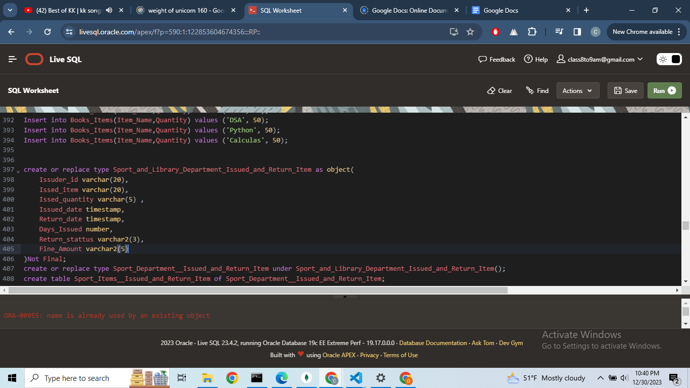

**Output:  
**





**Query:  
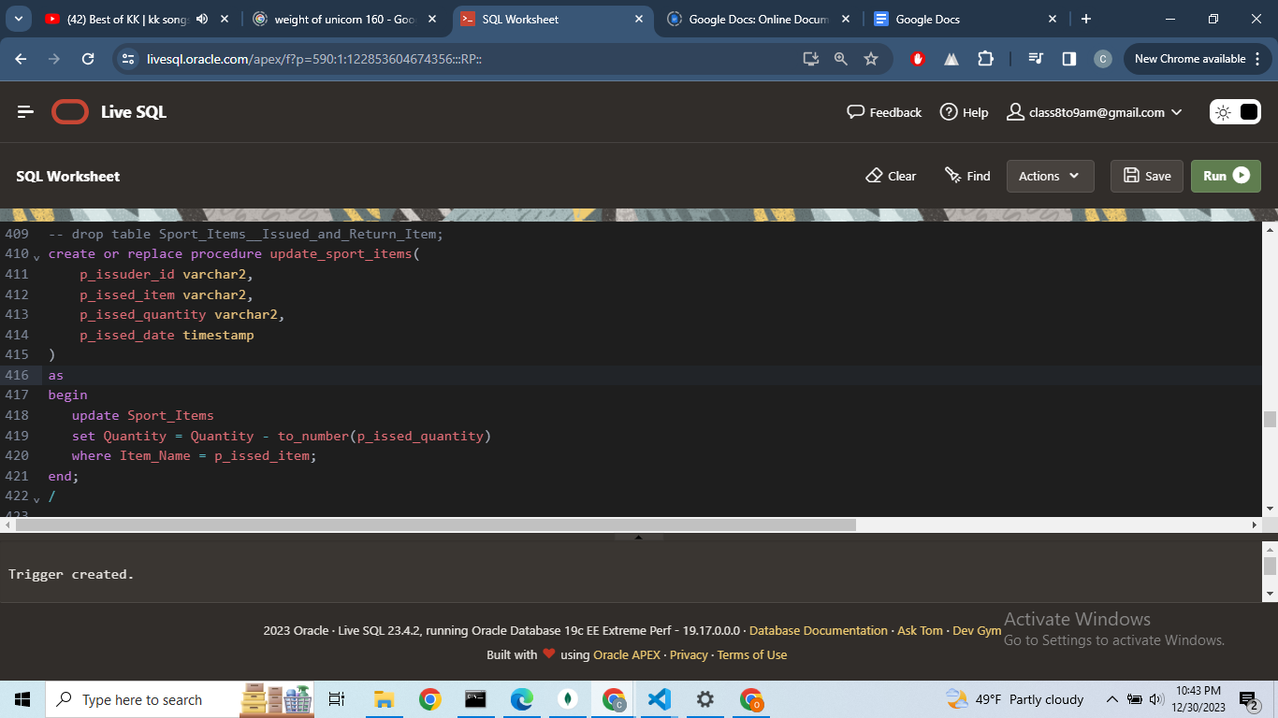**

**Output:  
**

**Query:  
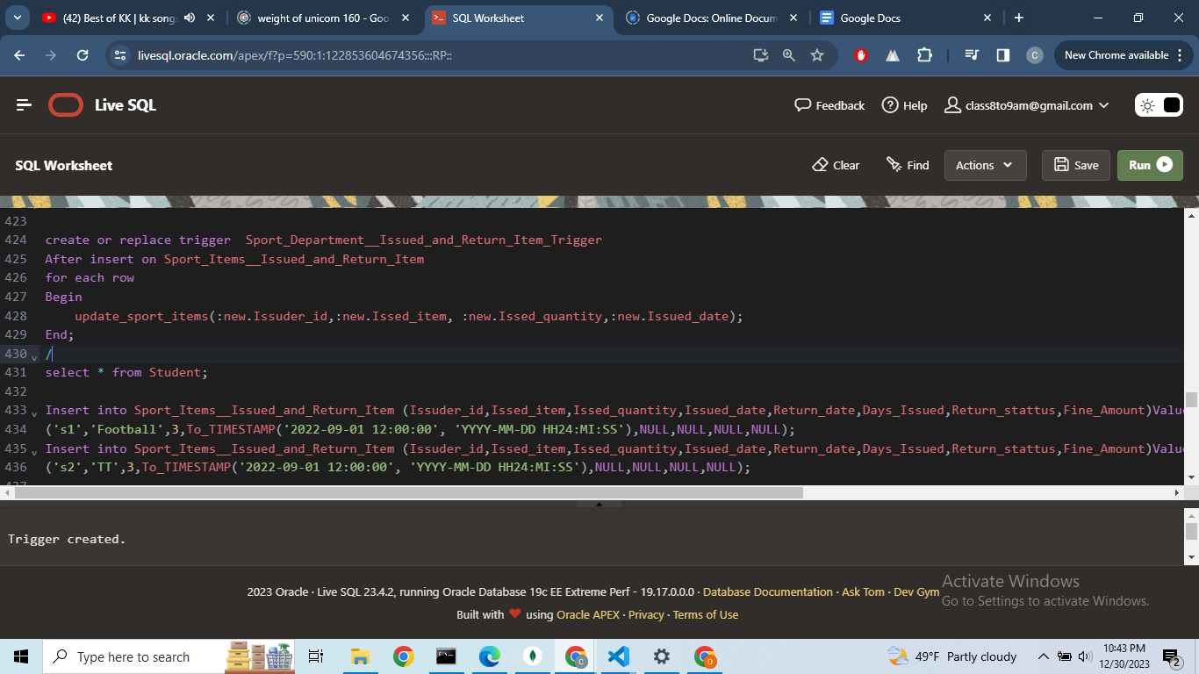**

**Output:  
**

**Query:**

**CREATE OR REPLACE PROCEDURE return_sport_items(**

**p_issuder_id VARCHAR2,**

**p_issed_item VARCHAR2,**

**p_issed_quantity VARCHAR2,**

**p_return_date TIMESTAMP**

**)**

**AS**

**v_total_return_quantity VARCHAR2(10);**

**v_quantity VARCHAR2(10);**

**v_days_diff NUMBER;**

**v_issued_date TIMESTAMP;**

**BEGIN**

**-- Use a cursor to handle multiple rows in the SELECT**

**FOR c IN (**

**SELECT Issed_quantity, Issued_date**

**FROM Sport_Items__Issued_and_Return_Item**

**WHERE Issuder_id = p_issuder_id**

**AND Issed_item = p_issed_item**

**)**

**LOOP**

**v_total_return_quantity := c.Issed_quantity;**

**v_issued_date := c.Issued_date;**

**END LOOP;**

**-- Use a cursor to handle multiple rows in the SELECT**

**FOR c IN (**

**SELECT Quantity**

**FROM Sport_Items**

**WHERE Item_Name = p_issed_item**

**)**

**LOOP**

**v_quantity := c.Quantity;**

**END LOOP;**

**-- Check if returned quantity is less than or equal to issued quantity**

**IF TO_NUMBER(p_issed_quantity) = TO_NUMBER(v_total_return_quantity) THEN**

**-- Update Sport_Items only if the condition is met**

**UPDATE Sport_Items**

**SET Quantity = TO_NUMBER(v_quantity) + TO_NUMBER(p_issed_quantity)**

**WHERE Item_Name = p_issed_item;**

**v_days_diff := EXTRACT(DAY FROM (p_return_date - v_issued_date));**

**-- Update existing row in Sport_Items__Issued_and_Return_Item**

**UPDATE Sport_Items__Issued_and_Return_Item**

**SET Return_date = p_return_date,**

**Days_Issued = v_days_diff,**

**Return_stattus = 'YES',**

**Fine_Amount =**

**CASE**

**WHEN v_days_diff > 10 AND v_days_diff <= 20 THEN 50**

**WHEN v_days_diff > 20 AND v_days_diff <= 30 THEN 100**

**ELSE 500**

**END**

**WHERE Issuder_id = p_issuder_id**

**AND Issed_item = p_issed_item;**

**DBMS_OUTPUT.PUT_LINE('Update');**

**ELSE**

**DBMS_OUTPUT.PUT_LINE('Sorry!!! Issued and Return quantity do not match.');**

**END IF;**

**END return_sport_items;**

**/**

**Output:  
**

**Inserting Values in Tables:  
  
Query:  
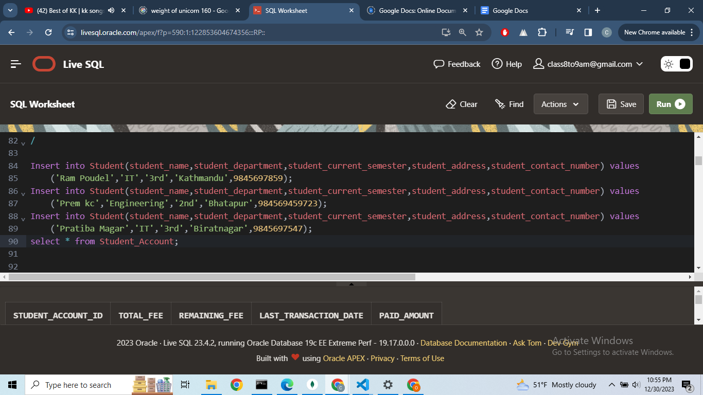  
  
Output:  
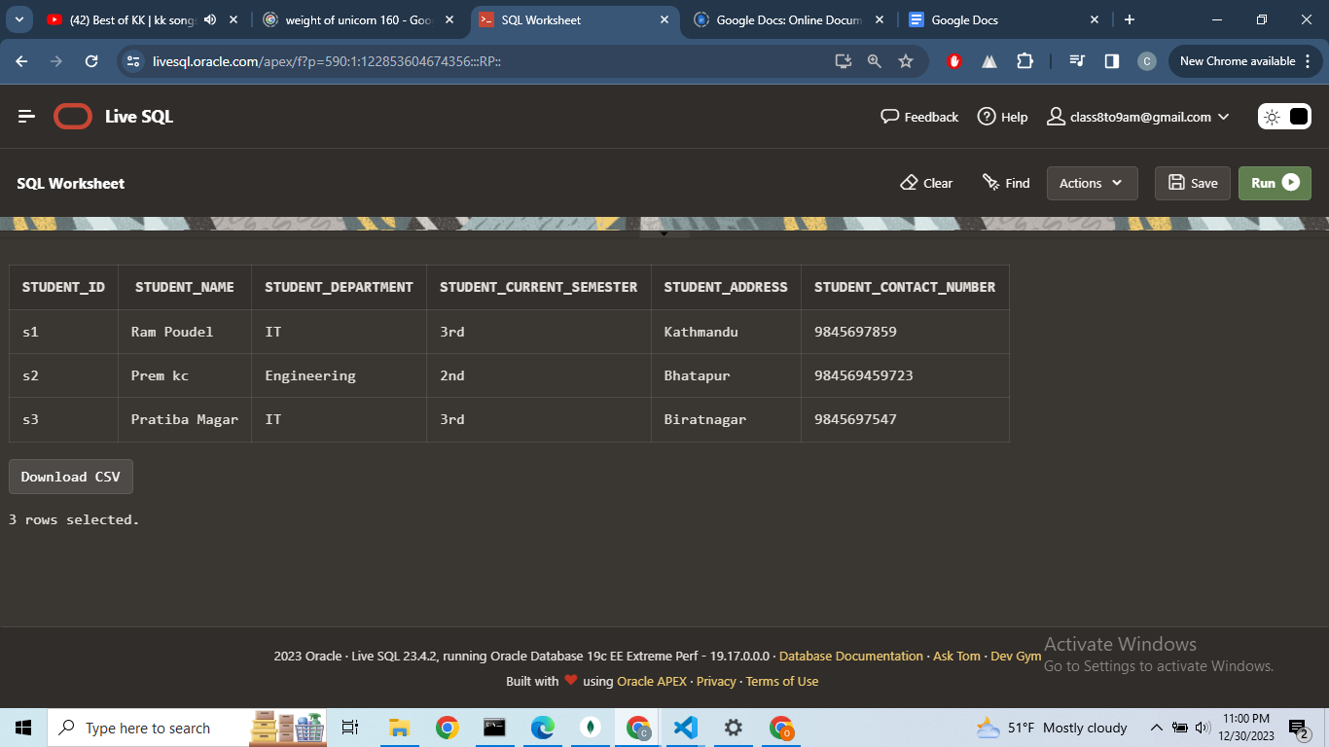**

**Query:  
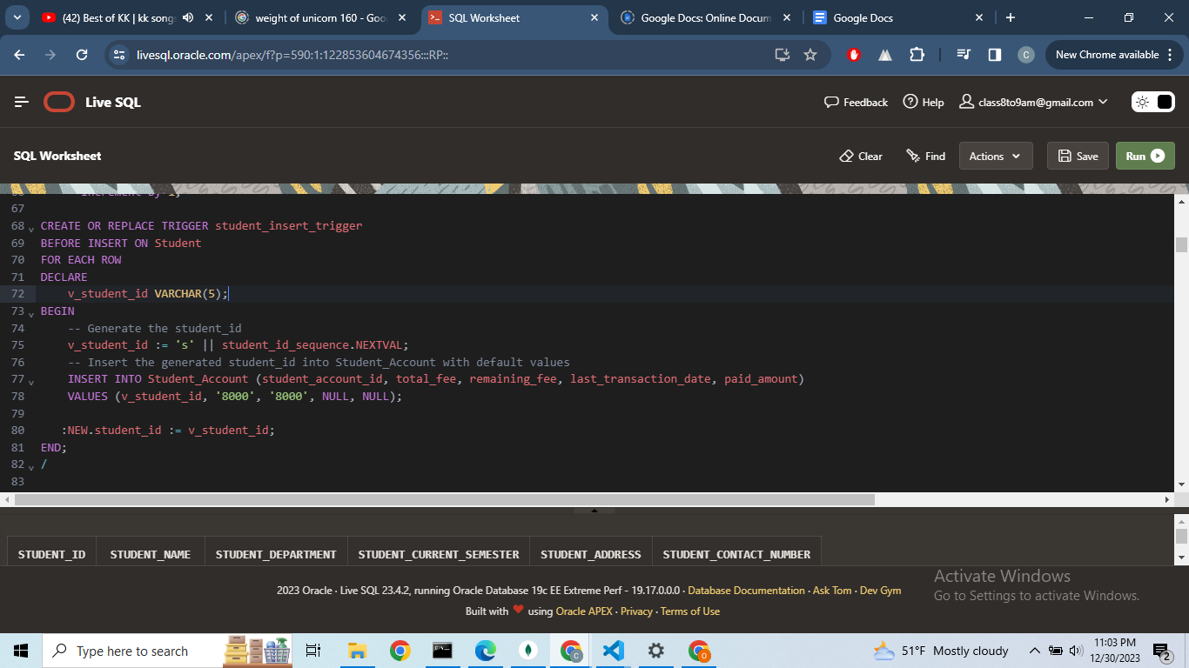  
  
  
  
select * from Student_Account;**

**Output:  
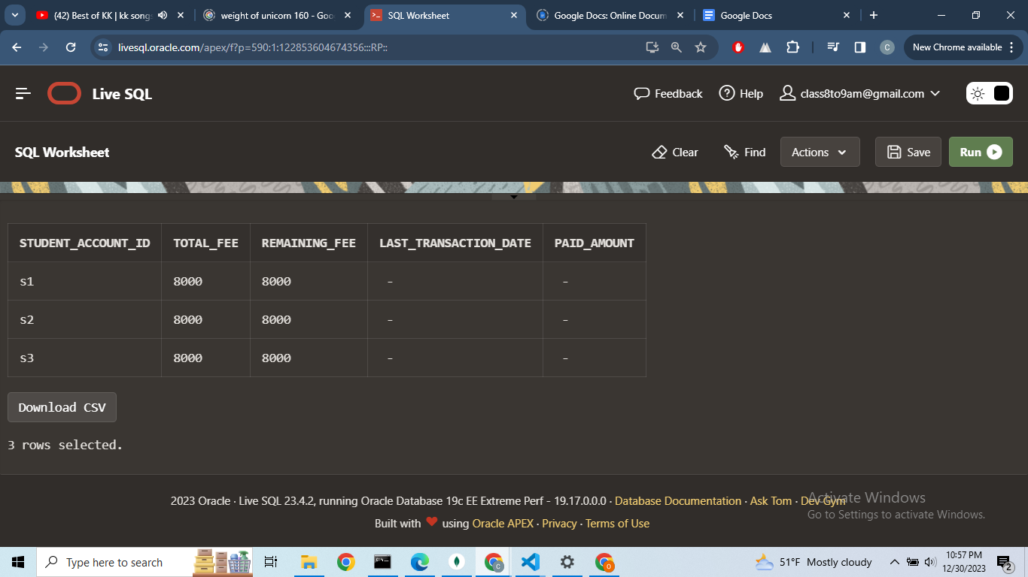**

**Query:**

**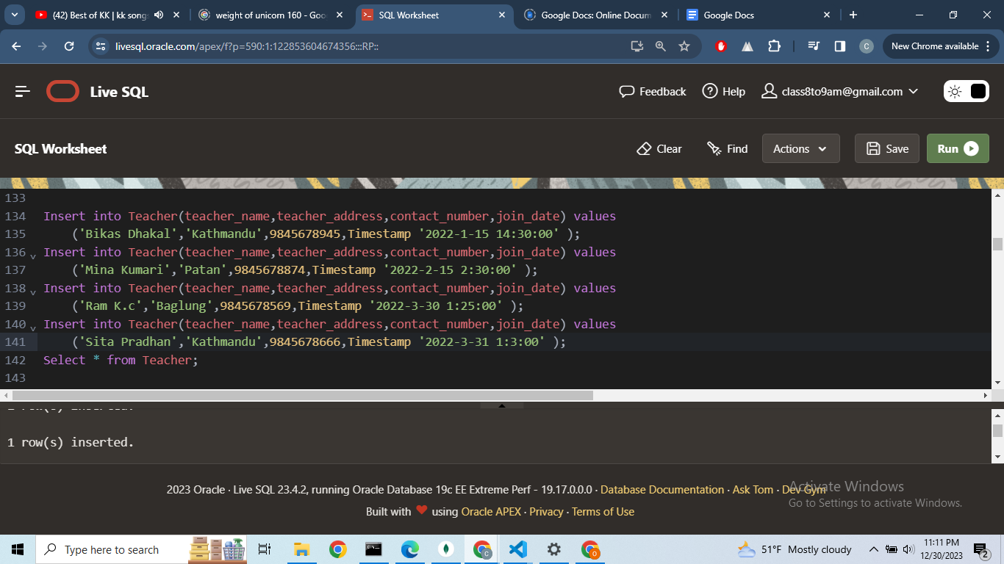  
  
  
Output:  
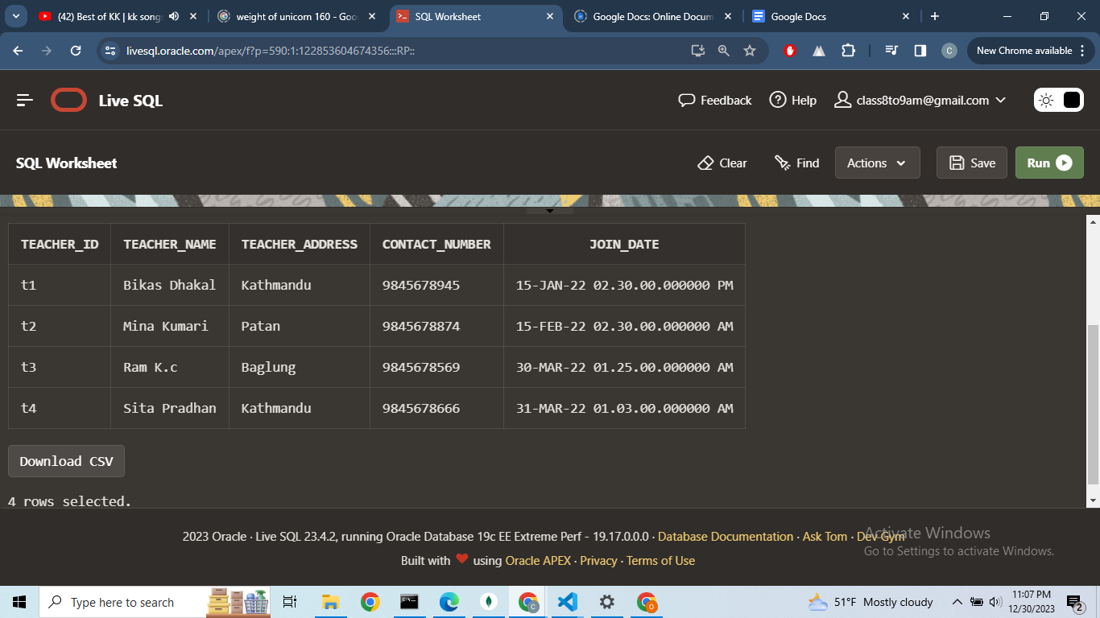  
  
  
  
Query:  
Select * from Teacher_account;**

**Output:  
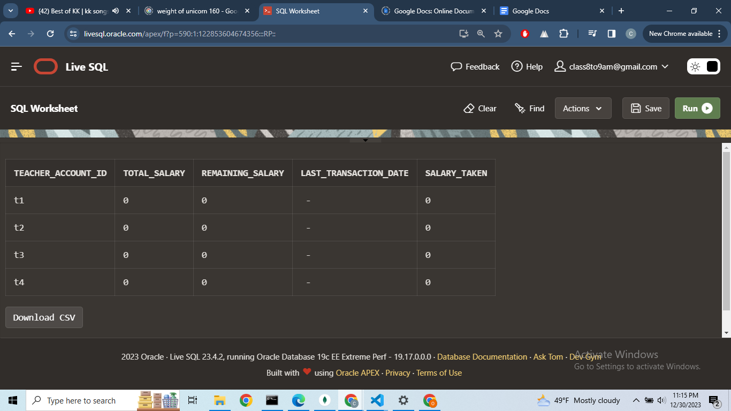**

**Query:  
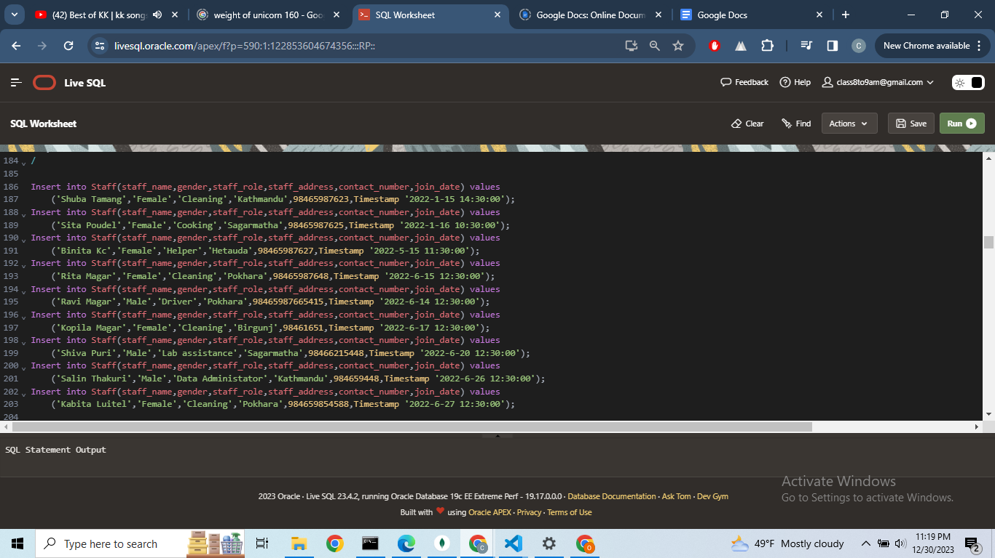  
  
  
Output:  
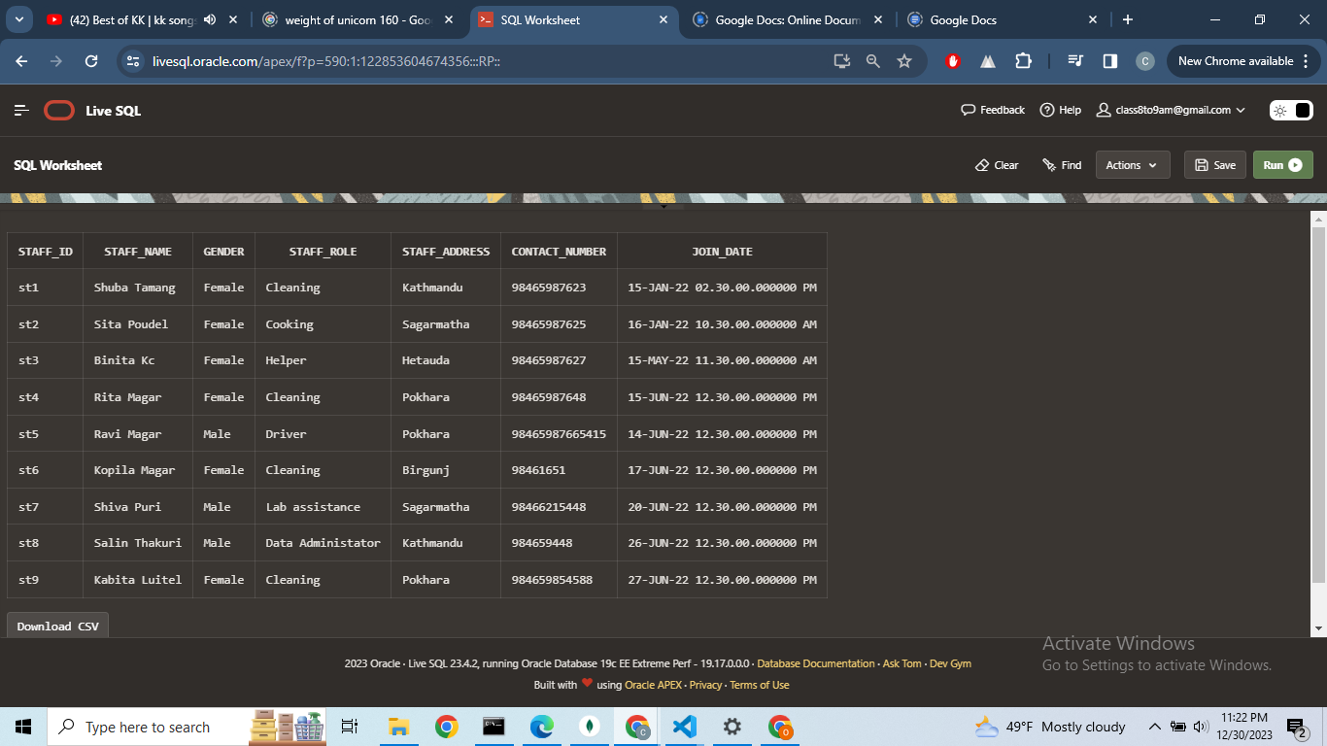**

**Query:**select * from Staff_account;  
Table is created automatically when Staff is created because of Trigger and Table staff_id_trigger and Staff_Account respectively

**Output:  
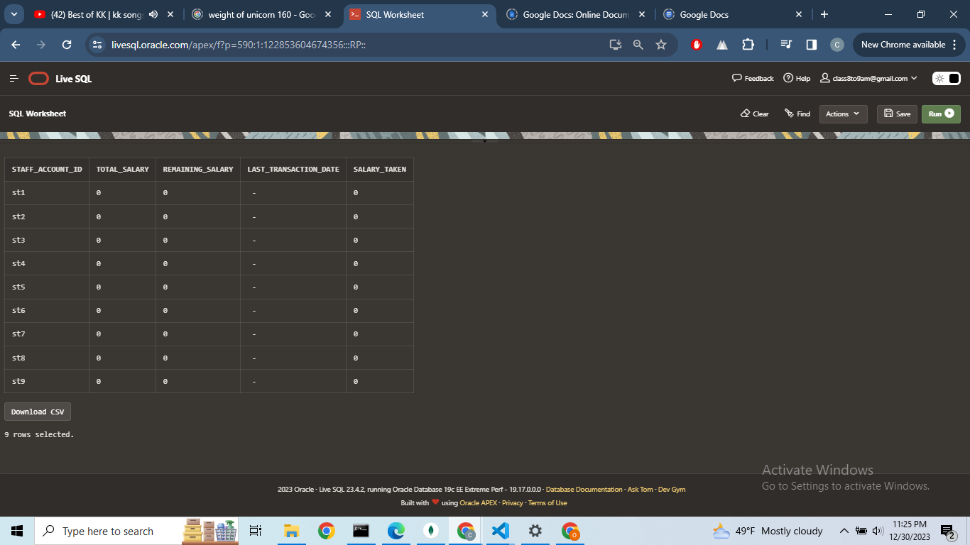**

**Query:  
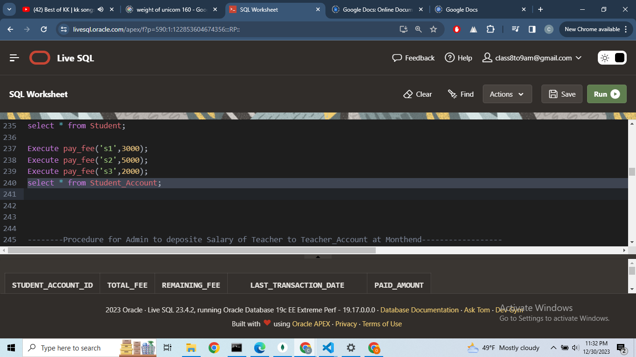  
  
  
  
  
Output:  
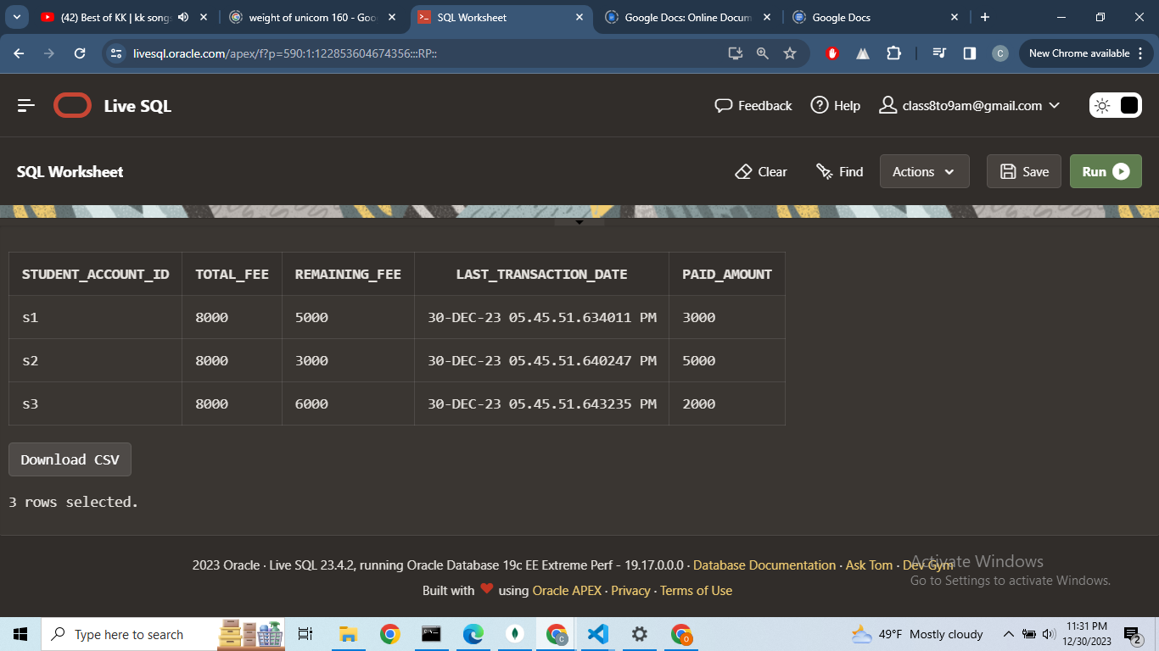**

**Query:  
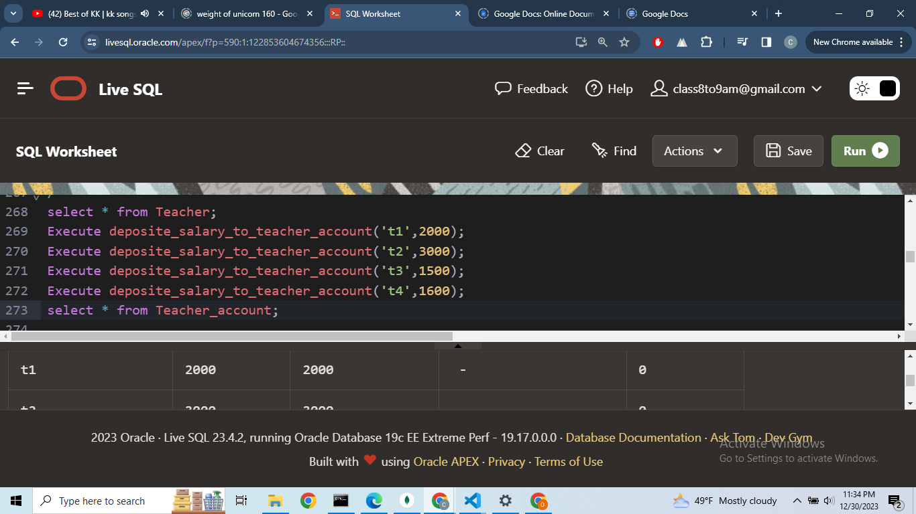  
  
  
  
OutPut:  
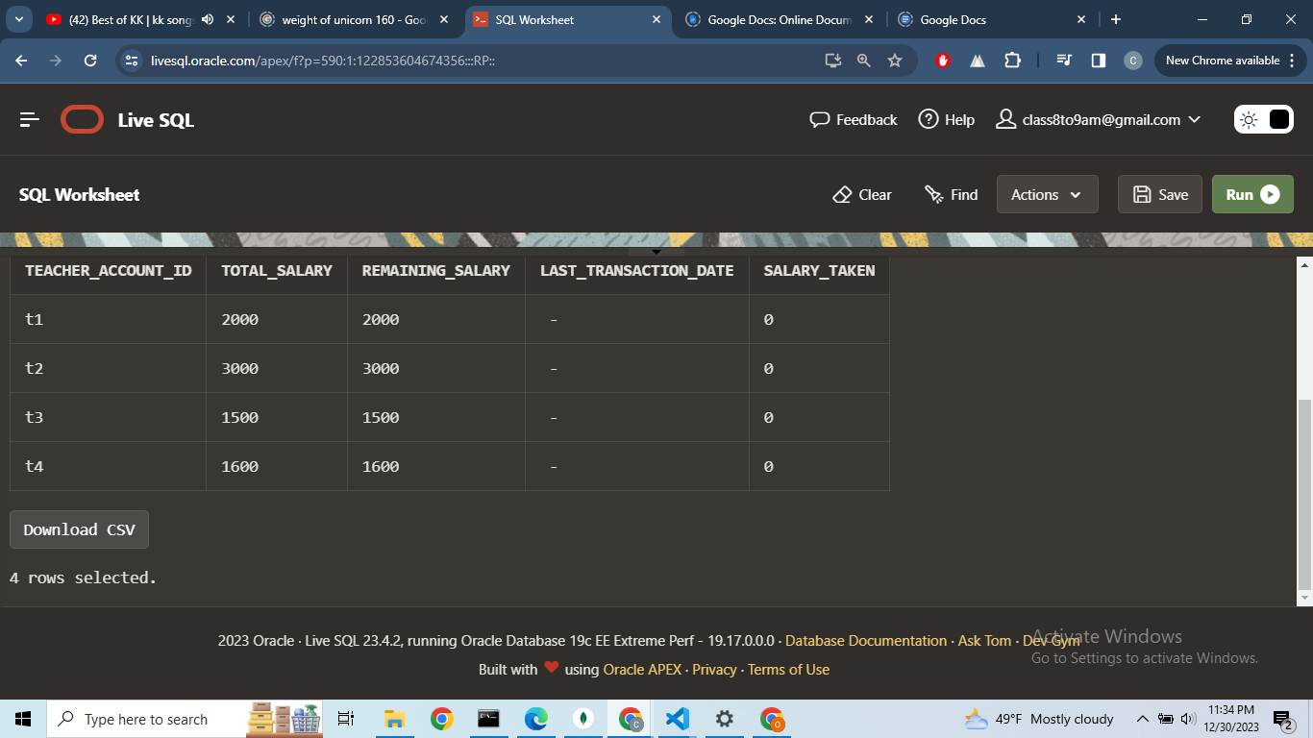**

**Query:  
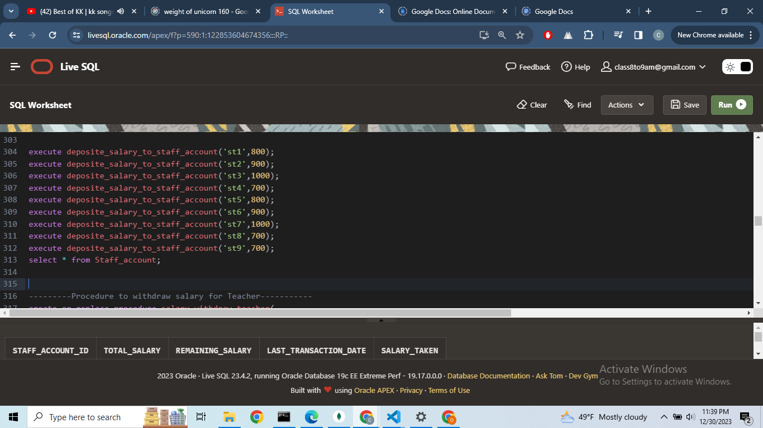  
  
  
  
Output:  
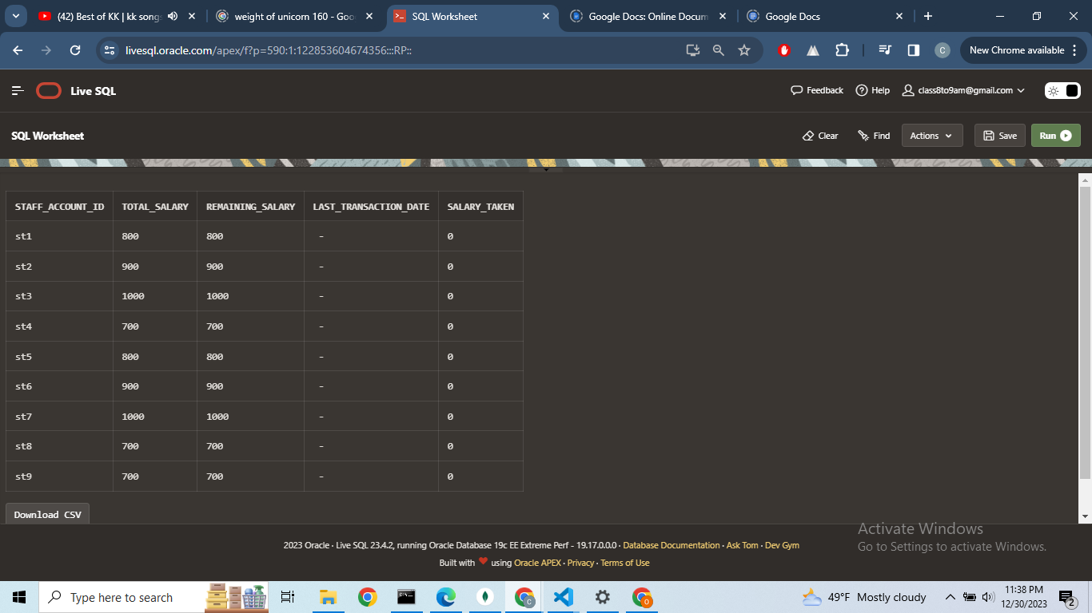  
  
  
  
  
  
  
  
Query:  
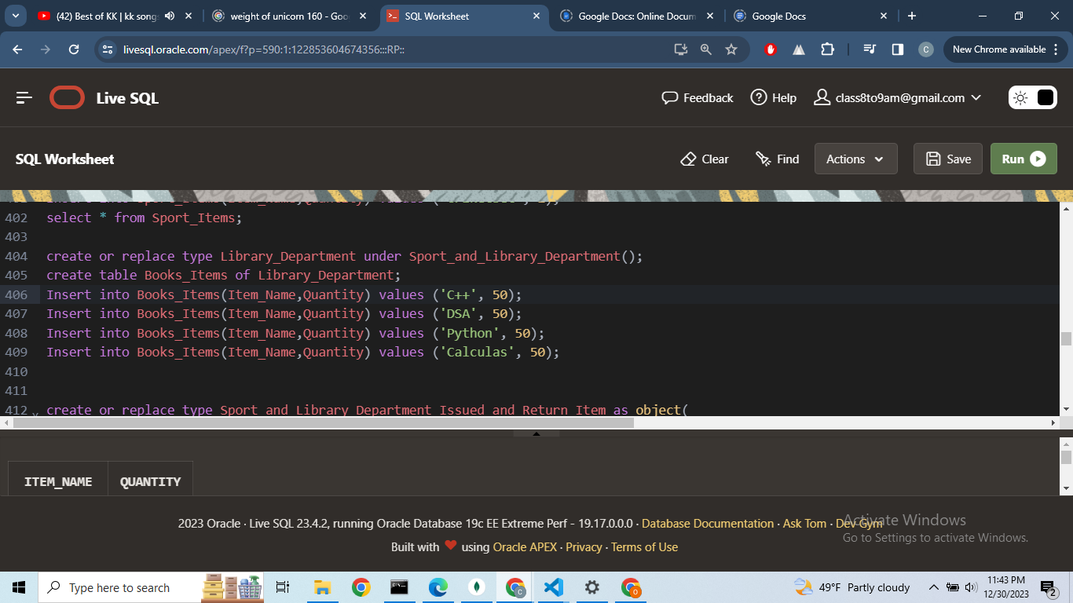  
  
  
  
Output:  
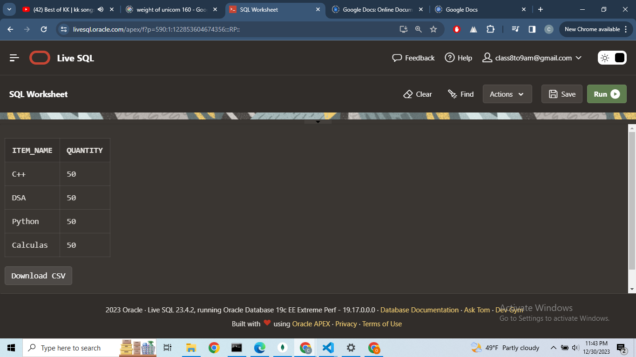  
  
  
  
  
  
  
  
  
  
Query:  
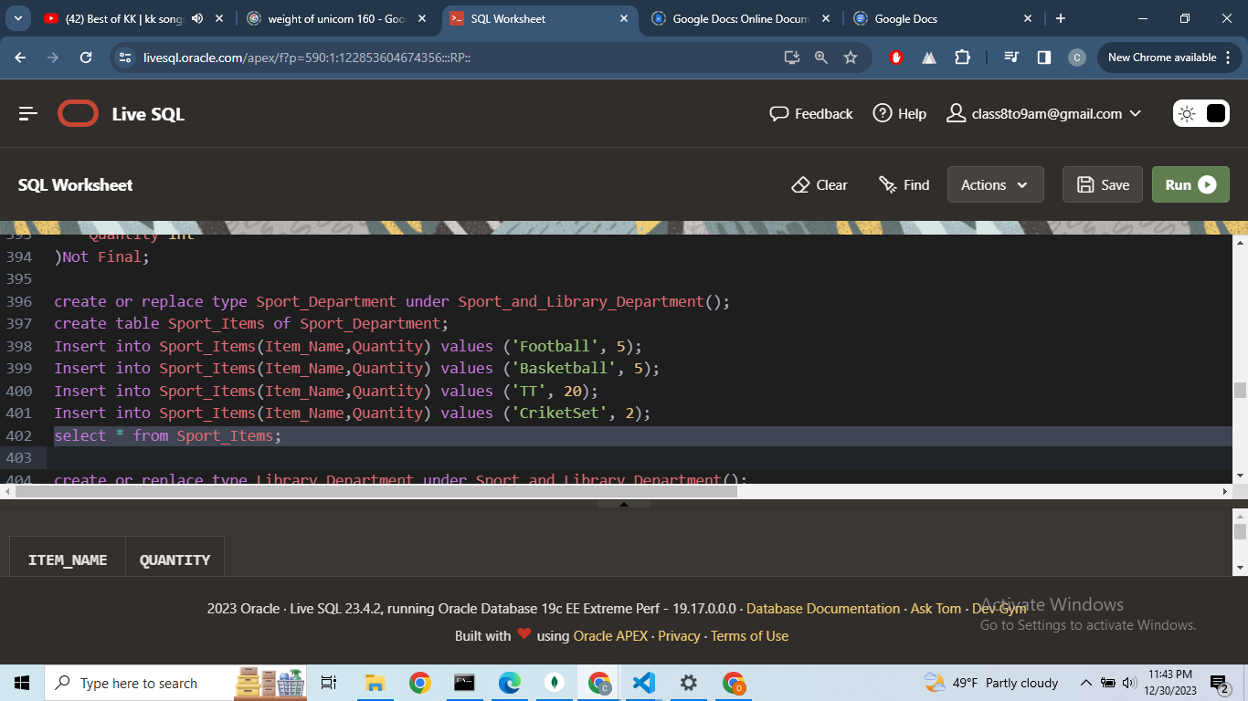  
  
Output:  
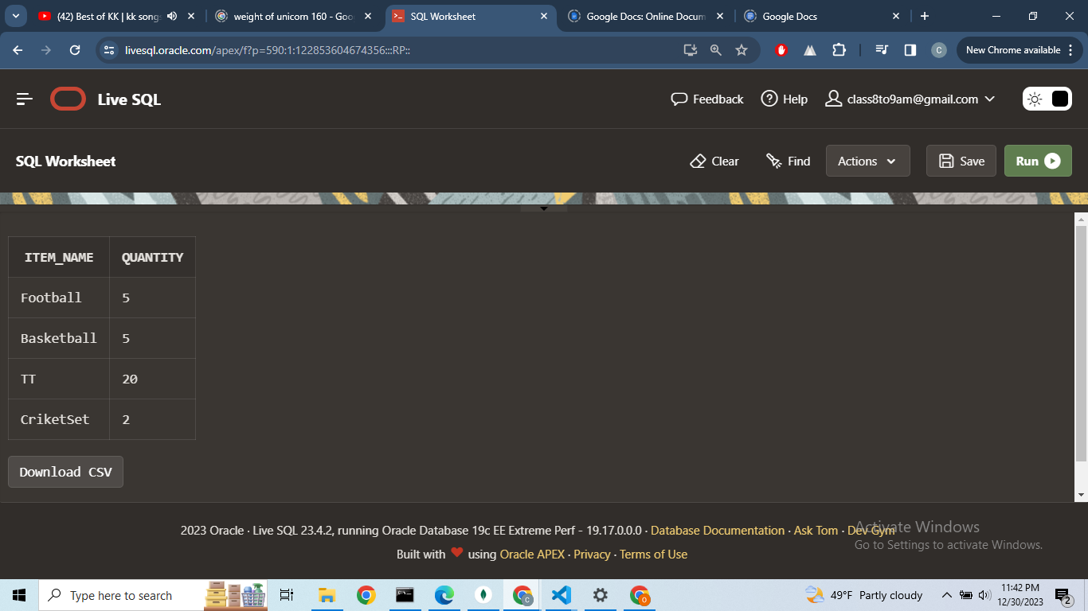**

**Query:  
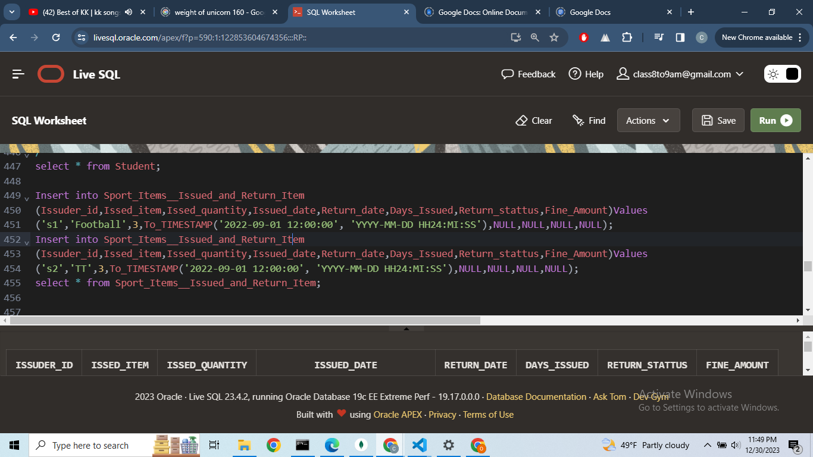**

**Output:  
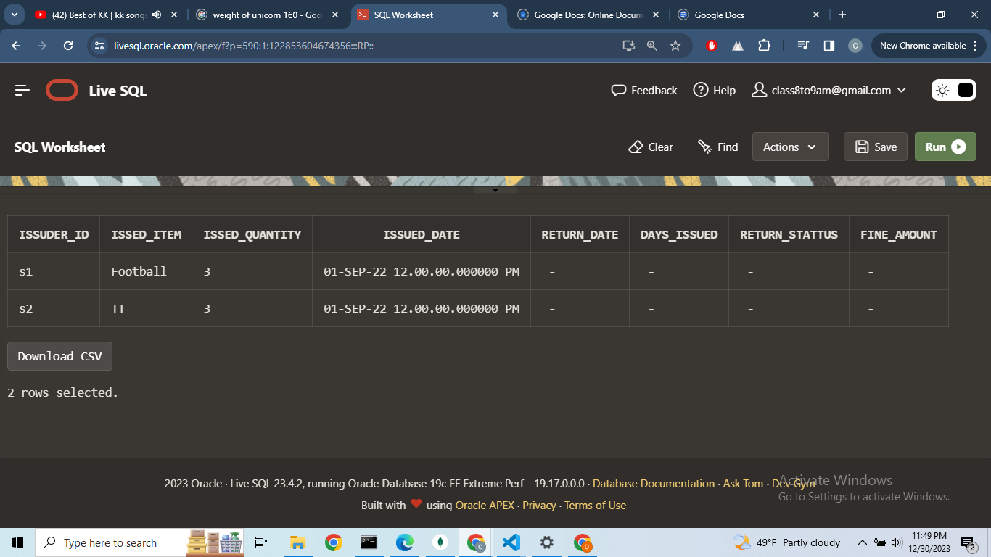  
  
  
  
  
  
  
  
  
  
  
Query:  
Execute return_sport_items('s1','Football',3,To_TIMESTAMP('2022-10-01 12:00:00', 'YYYY-MM-DD HH24:MI:SS'));  
  
Select * from return_sport_items;**

**Output:  
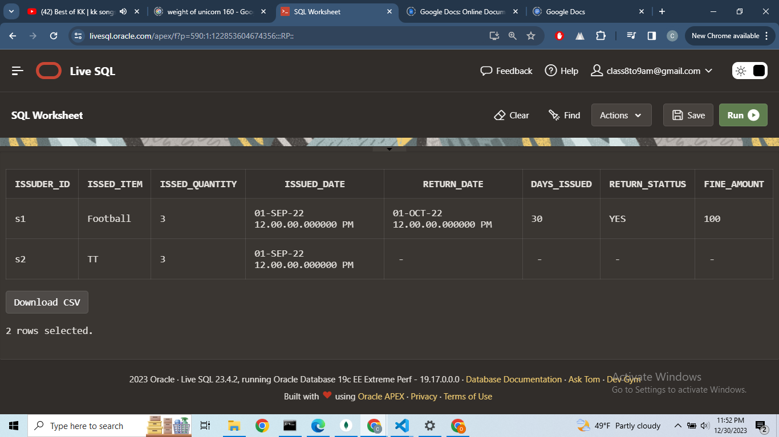**

**Descriptions:**

The script initializes by dropping existing tables, sequences, types, procedures, and triggers associated with the CollegeDataBase. It then proceeds to create essential sequences for entities likeCollege,Student,Teacher, Staff, Teacher_Account,Staff_Account,Sport_Items,Books_Items,

Sport_Items__Issued_and_Return_Item Tables .  
  
The Script defines tables for these entities,establishes triggers for generating unique IDs, and inserts sample data into the tables.Additionally,it creates procedures for handling financial transactions like fee payments and salary deposits and withdrawals for both teacher and staff members.  
  
It also include types and tables for managing items in the Sport and Library Department,including issuance and return of items. Foreign key constraint are added to maintain referential integrity.The join operations are demonstrated with examples, and OLAP function are used to calculate the total salary sum groped by gender in staff table.

## **Task Three: Demonstration of MongoDB Scripts and its working**

Using CollegeDataBase>

Query:  
use CollegeDataBase  
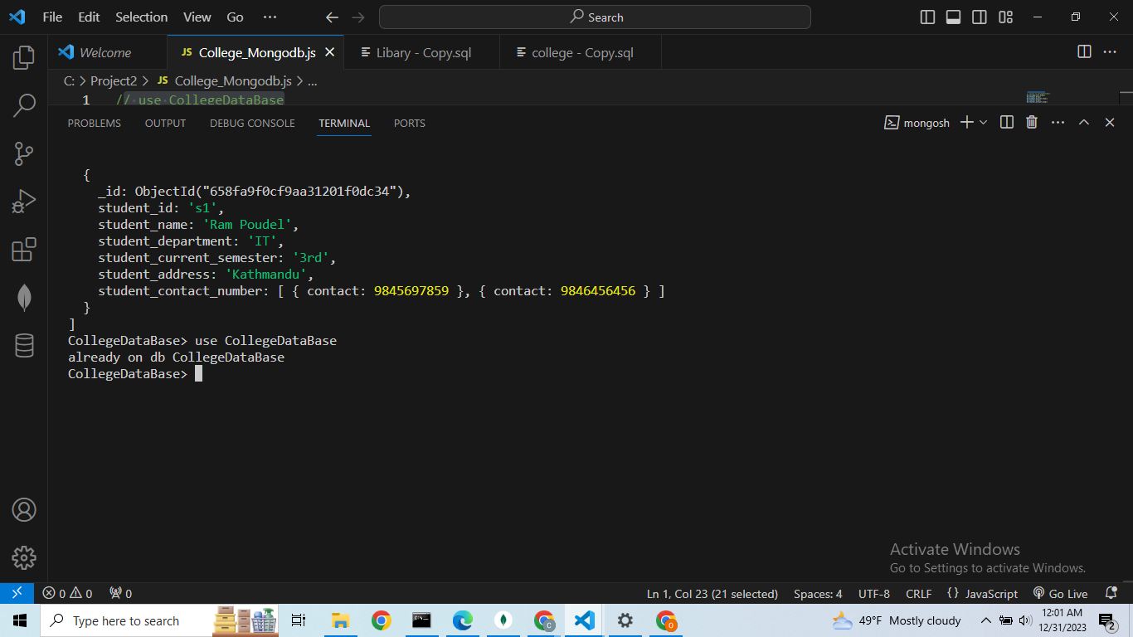

**Query**

**db.College_Info.drop()**

**db.Student.drop()**

**db.Student_Account.drop()**

**db.Teacher.drop()**

**db.Teacher_Account.drop()**

**db.Staff.drop()**

**db.Staff_Account.drop()**

**db.Sport_Items.drop()**

**db.Books_Items.drop()**

**db.Sport_Items__Issued_and_Return_Item.drop();**

**Output:  
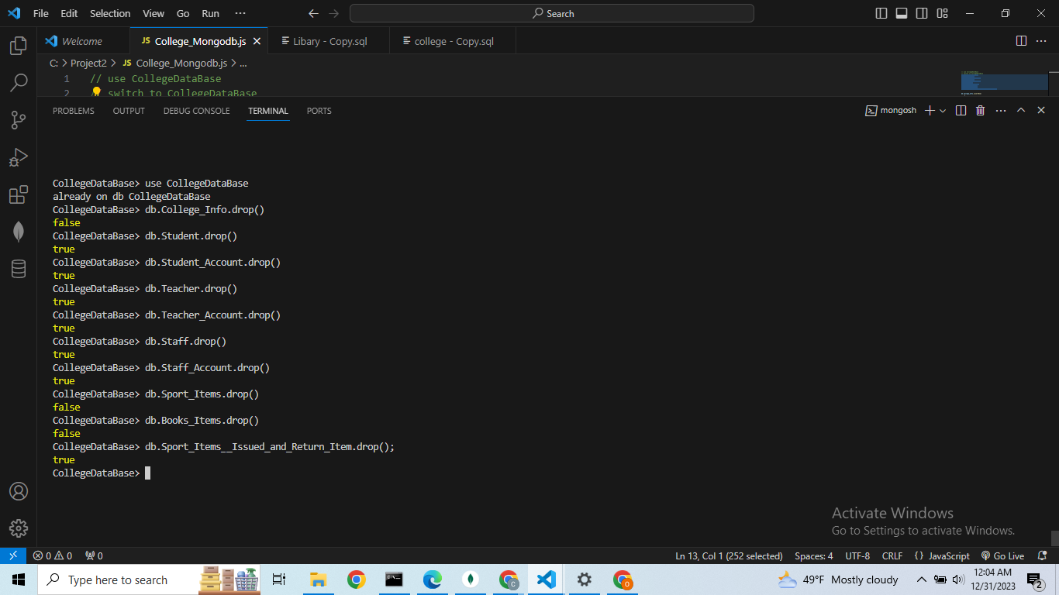**

**Query:**

**db.createCollection("College_Info");**

**db.College_Info.insertOne(**

**{**

**college_Name :'Sagarmatha College of Science and Technology',**

**post_code : 5256,**

**address : 'Sanepa',**

**contact : [**

**{**

**contact1:15156498**

**},**

**{**

**contact2:151515412**

**}**

**]**

**});**

**Output:  
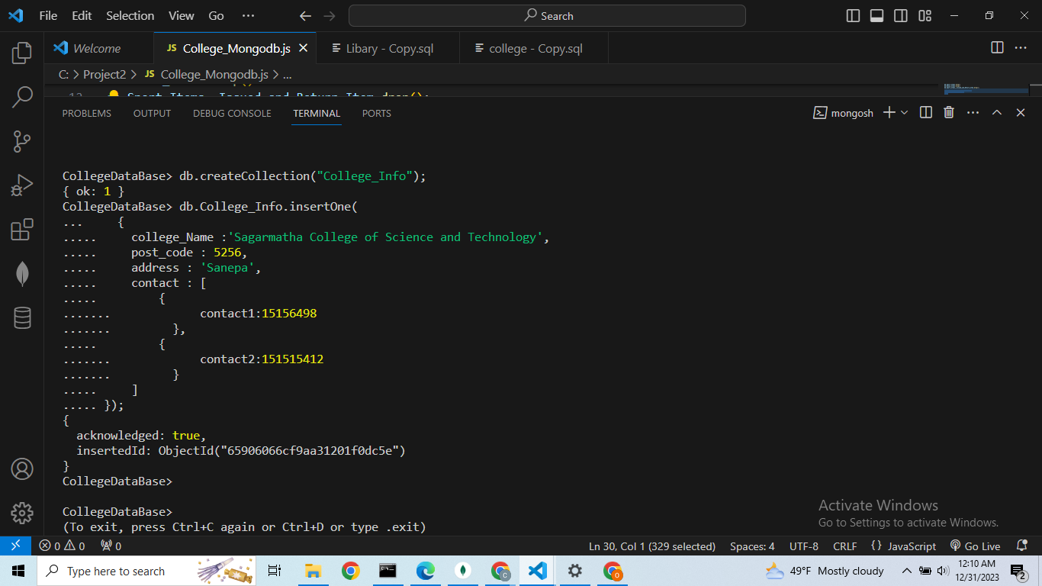**

**Query:**

**db.createCollection("Student");**

**db.Student.insertMany([**

**{**

**student_id : 's1',**

**student_name: 'Ram Poudel',**

**student_department: 'IT',**

**student_current_semester: '3rd',**

**student_address: 'Kathmandu',**

**student_contact_number: [**

**{**

**contact:9845697859**

**},**

**{**

**contact:9846456456**

**}**

**]**

**},**

**{**

**student_id : 's2',**

**student_name: 'Prem kc',**

**student_department: 'Engineering',**

**student_current_semester: '2nd',**

**student_address: 'Bhatapur',**

**student_contact_number: [**

**{**

**contact:984569459723**

**},**

**{**

**contact:9845694597141**

**}**

**]**

**},**

**{**

**student_id : 's3',**

**student_name: 'Pratiba Magar',**

**student_department: 'IT',**

**student_current_semester: '3rd',**

**student_address: 'Biratnagar',**

**student_contact_number: [**

**{**

**contact:9845697547**

**},**

**{**

**contact:9845697547**

**}**

**]**

**}**

**]);**

**Output:  
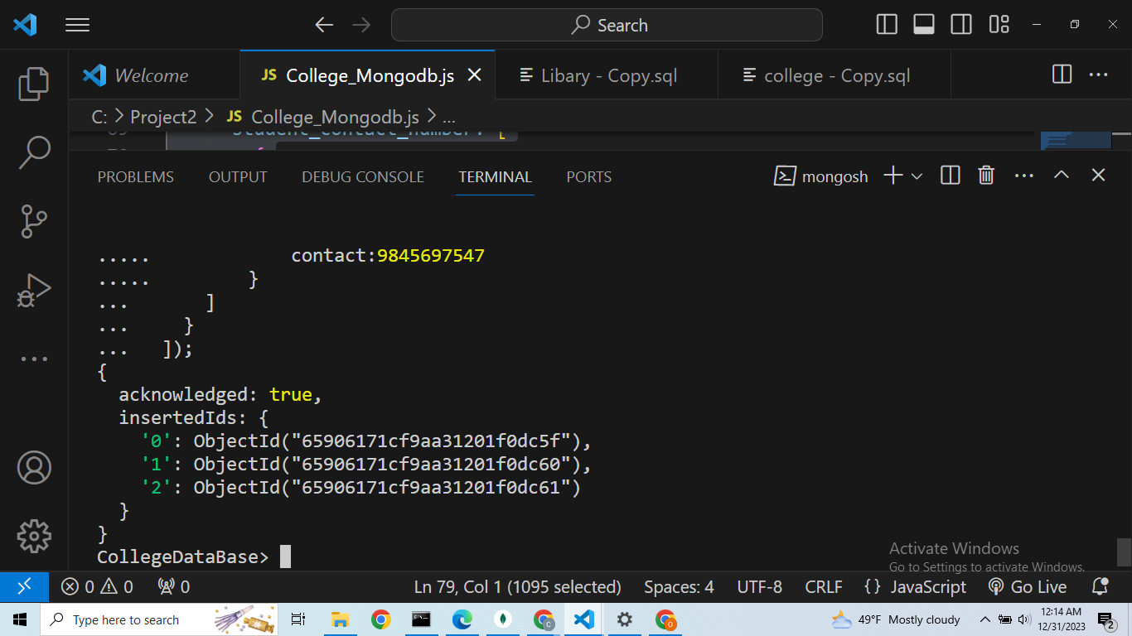**

**Query:**

**db.createCollection("Student_Account")**

**db.Student_Account.insertMany([**

**{**

**"STUDENT_ACCOUNT_ID": "s1",**

**"TOTAL_FEE": 8000,**

**"REMAINING_FEE": 5000,**

**"LAST_TRANSACTION_DATE": "2023-12-30T04:18:13.953Z",**

**"PAID_AMOUNT": 3000**

**},**

**{**

**"STUDENT_ACCOUNT_ID": "s2",**

**"TOTAL_FEE": 8000,**

**"REMAINING_FEE": 3000,**

**"LAST_TRANSACTION_DATE": "2023-12-30T04:18:57.018Z",**

**"PAID_AMOUNT": 5000**

**},**

**{**

**"STUDENT_ACCOUNT_ID": "s3",**

**"TOTAL_FEE": 8000,**

**"REMAINING_FEE": 6000,**

**"LAST_TRANSACTION_DATE": "2023-12-30T04:19:37.804Z",**

**"PAID_AMOUNT": 2000**

**}**

**]);**

**Output:  
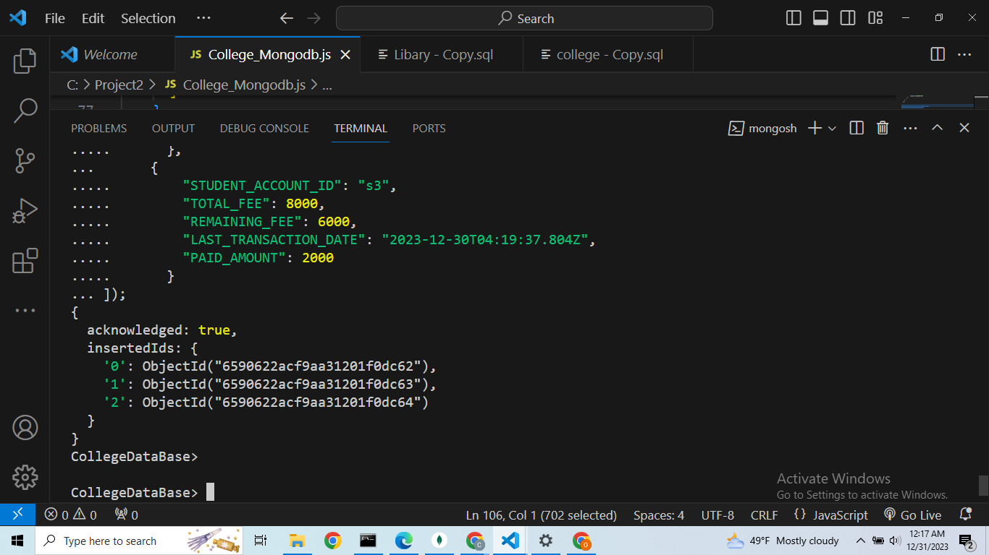**

**Query:**

**db.createCollection("Teacher");**

**db.Teacher.insertMany([**

**{**

**teacher_id : 't1',**

**teacher_name: 'Bikas Dhakal',**

**teacher_address: 'Kathmandu',**

**contact_number: [**

**{**

**contact1:9845678945**

**},**

**{**

**contact2:9845678945**

**}**

**],**

**join_date: ISODate('2022-01-15T14:30:00.000Z')**

**},**

**{**

**teacher_id : 't2',**

**teacher_name: 'Mina Kumari',**

**teacher_address: 'Patan',**

**contact_number: 9845678874[**

**{**

**contact1:9845678874**

**},**

**{**

**contact2:98456785615**

**}**

**],**

**join_date: ISODate('2022-02-15T02:30:00.000Z')**

**},**

**{**

**teacher_id : 't3',**

**teacher_name: 'Ram K.c',**

**teacher_address: 'Baglung',**

**contact_number: 9845678569[**

**{**

**contact1:9845678569**

**},**

**{**

**contact2:9845678566**

**}**

**],**

**join_date: ISODate('2022-03-30T01:25:00.000Z')**

**},**

**{**

**teacher_id : 't4',**

**teacher_name: 'Sita Pradhan',**

**teacher_address: 'Kathmandu',**

**contact_number: 9845678666[**

**{**

**contact1:9845678666**

**},**

**{**

**contact2:98456151545**

**}**

**],**

**join_date: ISODate('2022-03-31T01:03:00.000Z')**

**}**

**]);**

**Output:  
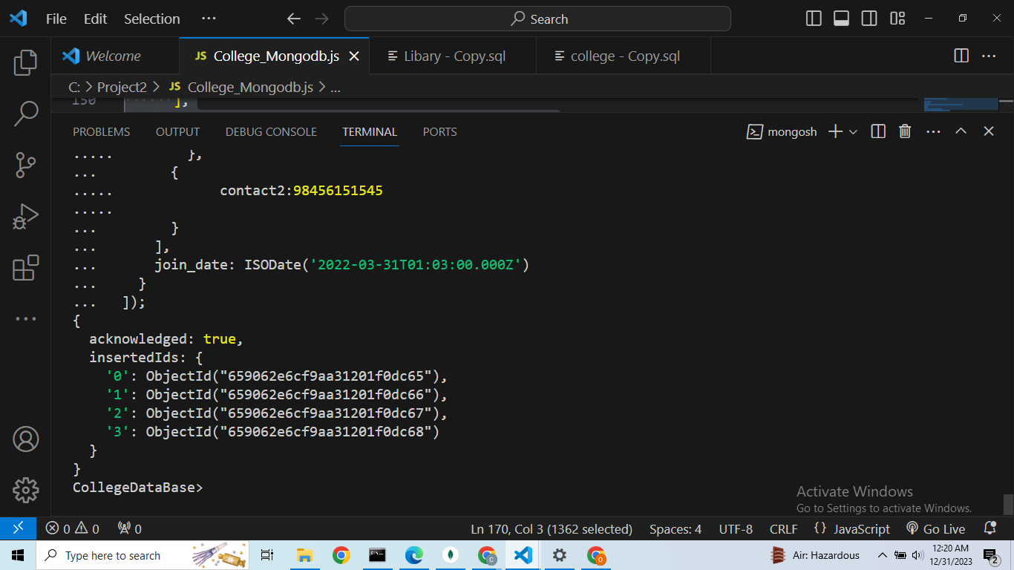Query:**

**db.createCollection("Teacher_Account");**

**db.Teacher_Account.insertMany([**

**{**

**"TEACHER_ACCOUNT_ID": "t1",**

**"TOTAL_SALARY": 2000,**

**"REMAINING_SALARY": 1300,**

**"LAST_TRANSACTION_DATE": "2023-12-30T04:47:34.259Z",**

**"SALARY_TAKEN": 700**

**},**

**{**

**"TEACHER_ACCOUNT_ID": "t2",**

**"TOTAL_SALARY": 3000,**

**"REMAINING_SALARY": 2500,**

**"LAST_TRANSACTION_DATE": "2023-12-30T04:47:34.266Z",**

**"SALARY_TAKEN": 500**

**},**

**{**

**"TEACHER_ACCOUNT_ID": "t3",**

**"TOTAL_SALARY": 1500,**

**"REMAINING_SALARY": 900,**

**"LAST_TRANSACTION_DATE": "2023-12-30T04:47:34.271Z",**

**"SALARY_TAKEN": 600**

**},**

**{**

**"TEACHER_ACCOUNT_ID": "t4",**

**"TOTAL_SALARY": 1600,**

**"REMAINING_SALARY": 700,**

**"LAST_TRANSACTION_DATE": "2023-12-30T04:47:34.275Z",**

**"SALARY_TAKEN": 900**

**}**

**])**

**Output:  
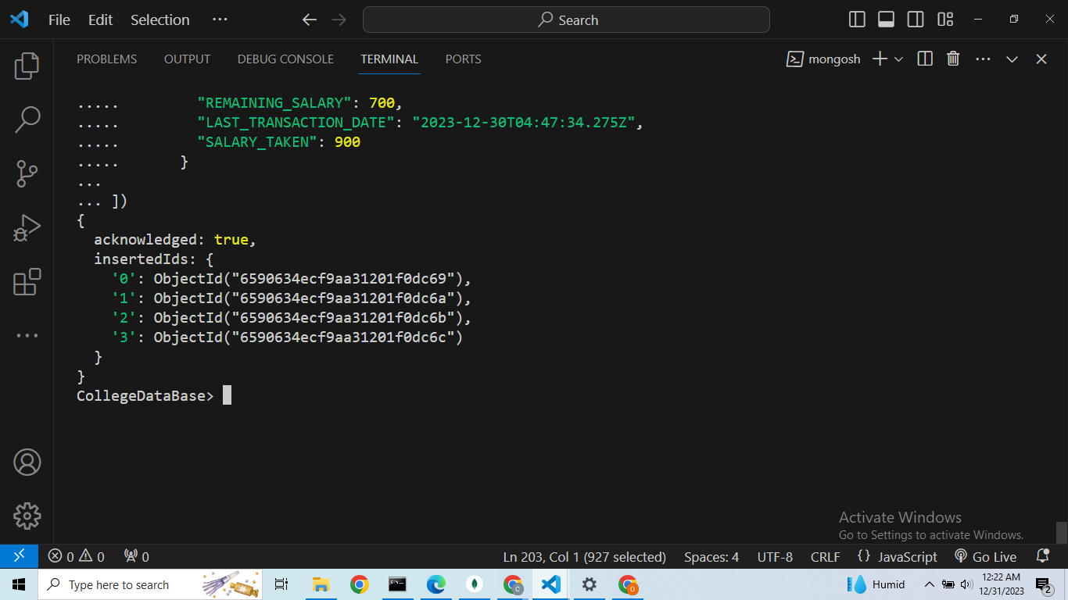**

**Query:**

**db.createCollection("Staff");**

**db.Staff.insertMany([**

**{**

**staff_id:'st1',**

**staff_name: 'Shuba Tamang',**

**gender:"Female",**

**staff_role: 'Cleaning',**

**staff_address: 'Kathmandu',**

**contact_number: [**

**{**

**contact1:98465987623**

**},**

**{**

**contact2:98456151454**

**}**

**],**

**join_date: new Date('2022-01-15T14:30:00')**

**},**

**{ staff_id:'st2',**

**staff_name: 'Sita Poudel',**

**gender:"Female",**

**staff_role: 'Cooking',**

**staff_address: 'Sagarmatha',**

**contact_number:[**

**{**

**contact1:98465987625**

**},**

**{**

**contact2:9845615444**

**}**

**],**

**join_date: new Date('2022-01-16T10:30:00')**

**},**

**{ staff_id:'st3',**

**staff_name: 'Binita Kc',**

**gender:"Female",**

**staff_role: 'Helper',**

**staff_address: 'Hetauda',**

**contact_number:[**

**{**

**contact1:98465987627**

**},**

**{**

**contact2:9845611215**

**}**

**],**

**join_date: new Date('2022-05-15T11:30:00')**

**},**

**{**

**staff_id:'st4' ,**

**staff_name: 'Rita Magar',**

**gender:"Female",**

**staff_role: 'Cleaning',**

**staff_address: 'Pokhara',**

**contact_number: [**

**{**

**contact1:98465987648**

**},**

**{**

**contact2:98456155545**

**}**

**],**

**join_date: new Date('2022-06-15T12:30:00')**

**},**

**{**

**staff_id: "st5",**

**staff_name: "Ravi Magar",**

**gender: "Male",**

**staff_role: "Driver",**

**staff_address: "Pokhara",**

**contact_number:[**

**{**

**contact1:98465987665415**

**},**

**{**

**contact2:984561556415**

**}**

**],**

**join_date: ISODate('2022-06-14T12:30:00.000Z')**

**},**

**{**

**staff_id : "st6",**

**staff_name : "Kopila Magar",**

**gender : "Female",**

**staff_role : "Cleaning",**

**staff_address : "Birgunj",**

**contact_number : [**

**{**

**contact1:98461651**

**},**

**{**

**contact2:98456545**

**}**

**],**

**join_date : ISODate('2022-06-17T12:30:00.000Z')**

**},**

**{**

**staff_id : "st7",**

**staff_name : "Shiva Puri",**

**gender : "Male",**

**staff_role : "Lab Assistance",**

**staff_address : "Sagarmatha",**

**contact_number: [**

**{**

**contact1:98466215448**

**},**

**{**

**contact2:9845654118**

**}**

**],**

**join_date : ISODate('2022-06-20T12:30:00.000Z')**

**},**

**{**

**staff_id : "st8",**

**staff_name : "Salin Thakuri",**

**gender : "Male",**

**staff_role : "Data Administrator",**

**staff_addres : "Kathmandu",**

**contact_number : [**

**{**

**contact1:984659448**

**},**

**{**

**contact2:9845655215**

**}**

**],**

**join_date : ISODate('2022-06-26T12:30:00.000Z')**

**},**

**{**

**staff_id : "st9",**

**staff_name : "Kabita Luitel",**

**gender : "Female",**

**staff_role : "Cleaning",**

**staff_address : "Pokhara",**

**contact_number : [**

**{**

**contact1:984659854588**

**},**

**{**

**contact2:984565521551**

**}**

**],**

**join_date : ISODate('2022-06-27T12:30:00.000Z')**

**},**

**]);**

**Output:  
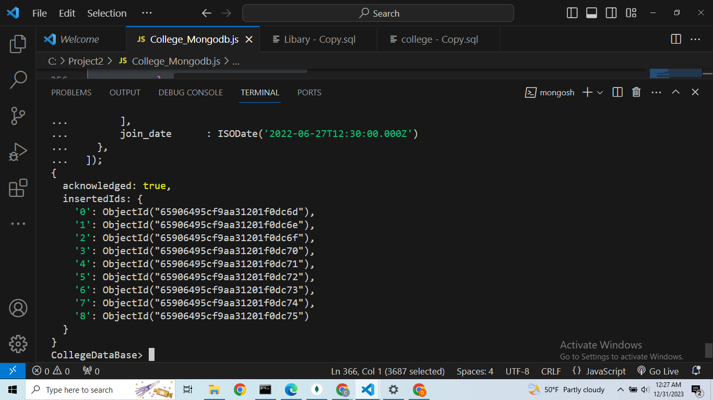**

**Query:**

**db.createCollection("Staff_Account");**

**db.Staff_Account.insertMany([**

**{**

**"STAFF_ACCOUNT_ID": "st5",**

**"TOTAL_SALARY": 800,**

**"REMAINING_SALARY": 650,**

**"LAST_TRANSACTION_DATE": ISODate('2023-12-30T10:26:44.777Z'),**

**"SALARY_TAKEN": 150**

**},**

**{**

**"STAFF_ACCOUNT_ID": "st6",**

**"TOTAL_SALARY": 900,**

**"REMAINING_SALARY": 740,**

**"LAST_TRANSACTION_DATE": ISODate('2023-12-30T10:26:44.784Z'),**

**"SALARY_TAKEN": 160**

**},**

**{**

**"STAFF_ACCOUNT_ID": "st7",**

**"TOTAL_SALARY": 1000,**

**"REMAINING_SALARY": 950,**

**"LAST_TRANSACTION_DATE": ISODate('2023-12-30T10:26:44.791Z'),**

**"SALARY_TAKEN": 50**

**},**

**{**

**"STAFF_ACCOUNT_ID": "st8",**

**"TOTAL_SALARY": 700,**

**"REMAINING_SALARY": 0,**

**"LAST_TRANSACTION_DATE": ISODate('2023-12-30T10:26:44.795Z'),**

**"SALARY_TAKEN": 700**

**},**

**{**

**"STAFF_ACCOUNT_ID": "st9",**

**"TOTAL_SALARY": 700,**

**"REMAINING_SALARY": 700,**

**"LAST_TRANSACTION_DATE": null,**

**"SALARY_TAKEN": 0**

**},**

**{**

**"STAFF_ACCOUNT_ID": "st1",**

**"TOTAL_SALARY": 800,**

**"REMAINING_SALARY": 600,**

**"LAST_TRANSACTION_DATE": ISODate('2023-12-30T10:26:44.754Z'),**

**"SALARY_TAKEN": 200**

**},**

**{**

**"STAFF_ACCOUNT_ID": "st2",**

**"TOTAL_SALARY": 900,**

**"REMAINING_SALARY": 300,**

**"LAST_TRANSACTION_DATE": ISODate('2023-12-30T10:26:44.761Z'),**

**"SALARY_TAKEN": 600**

**},**

**{**

**"STAFF_ACCOUNT_ID": "st3",**

**"TOTAL_SALARY": 1000,**

**"REMAINING_SALARY": 500,**

**"LAST_TRANSACTION_DATE": ISODate('2023-12-30T10:26:44.766Z'),**

**"SALARY_TAKEN": 500**

**},**

**{**

**"STAFF_ACCOUNT_ID": "st4",**

**"TOTAL_SALARY": 700,**

**"REMAINING_SALARY": 400,**

**"LAST_TRANSACTION_DATE": ISODate('2023-12-30T10:26:44.773Z'),**

**"SALARY_TAKEN": 300**

**}**

**]);**

**Output:  
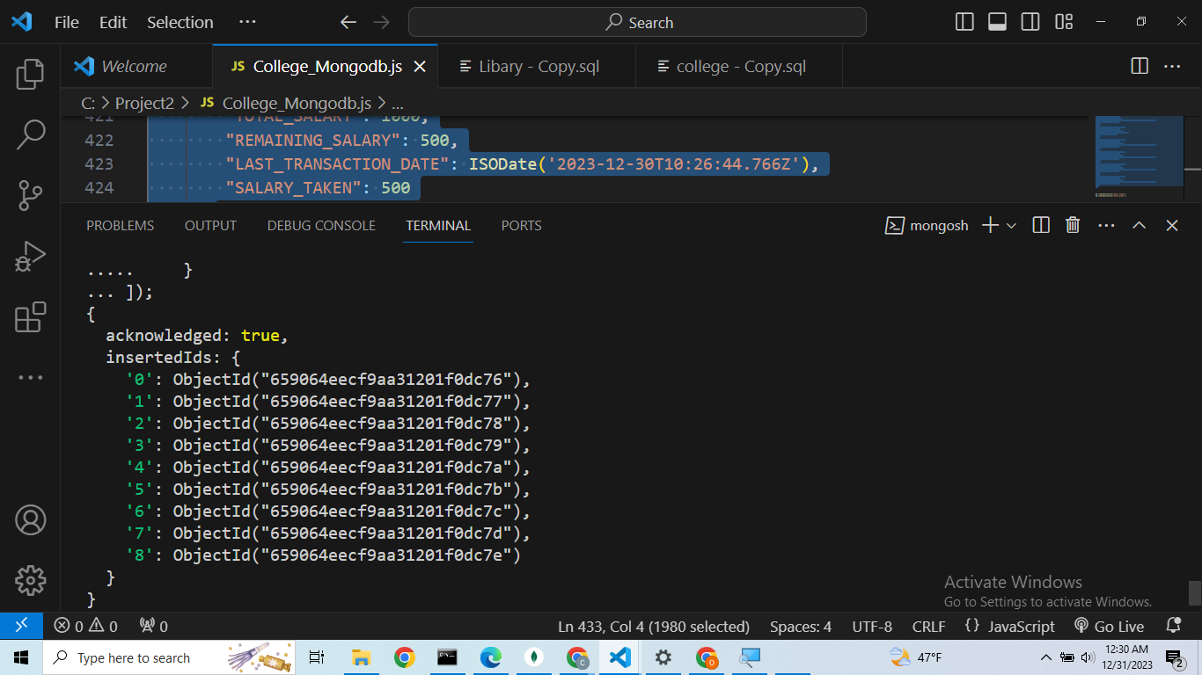  
  
  
  
  
  
  
  
  
  
  
  
  
  
Query:**

**db.createCollection("Sport_Items");**

**db.Sport_Items.insertMany([**

**{ Item_Name: 'Football',**

**Quantity: 5**

**},**

**{ Item_Name: 'Basketball',**

**Quantity: 5**

**},**

**{ Item_Name: 'TT',**

**Quantity: 20**

**},**

**{ Item_Name: 'CricketSet',**

**Quantity: 2**

**}**

**]);**

**Output:  
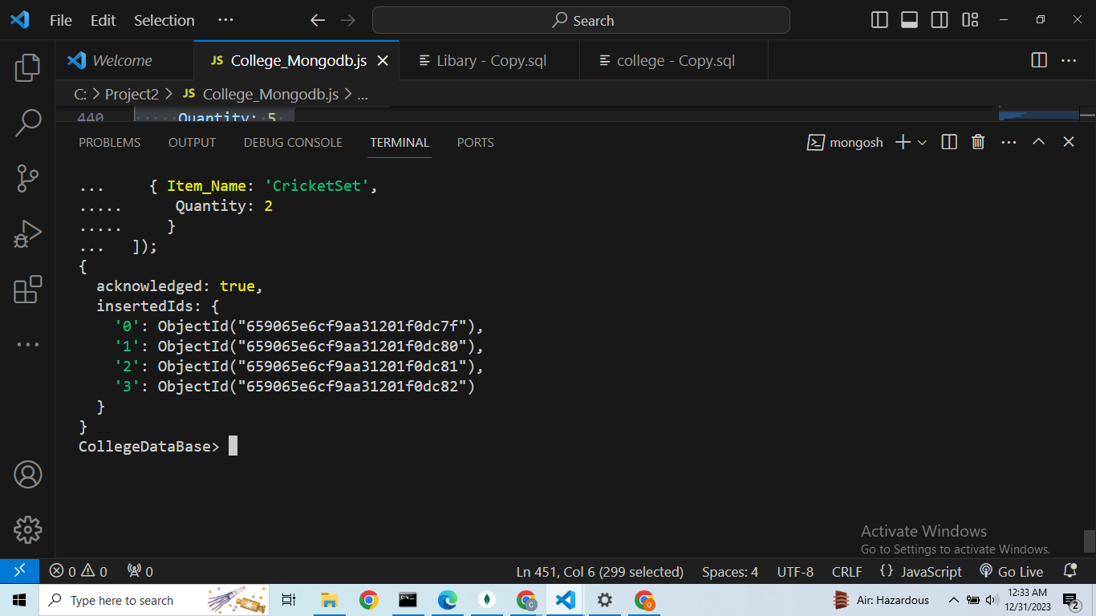**

**Query:**

**db.createCollection("Books_Items");**

**db.Books_Items.insertMany([**

**{ Item_Name: 'C++',**

**Quantity: 50**

**},**

**{ Item_Name: 'DSA',**

**Quantity: 50**

**},**

**{ Item_Name: 'Python',**

**Quantity:50**

**},**

**{ Item_Name: 'Calculas',**

**Quantity: 50**

**}**

**]);**

**Output:  
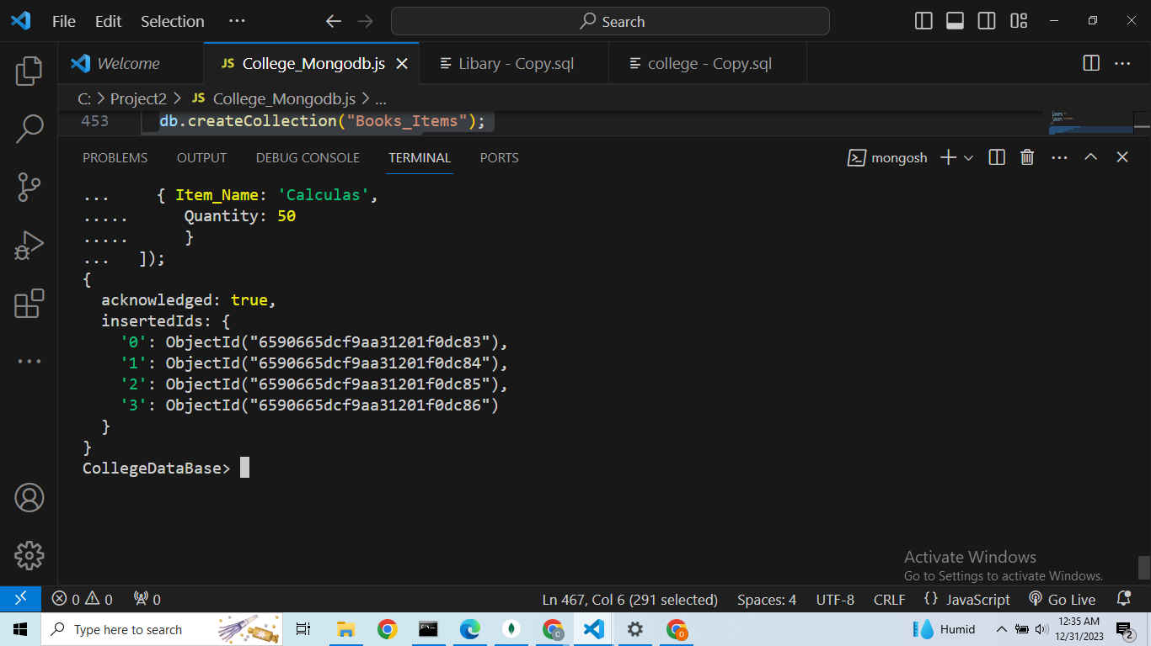**

**Query:**

**db.createCollection("Sport_Items__Issued_and_Return_Item")**

**db.Sport_Items__Issued_and_Return_Item.insertMany([**

**{**

**"ISSUDER_ID": "s1",**

**"ISSED_ITEM": "Football",**

**"ISSED_QUANTITY": 3,**

**"ISSUED_DATE": "2022-09-01T12:00:00.000Z",**

**"RETURN_DATE": "2022-10-01T12:00:00.000Z",**

**"DAYS_ISSUED": 30,**

**"RETURN_STATTUS": "YES",**

**"FINE_AMOUNT": 100**

**},**

**{**

**"ISSUDER_ID": "s2",**

**"ISSED_ITEM": "TT",**

**"ISSED_QUANTITY": 3,**

**"ISSUED_DATE": "2022-09-01T12:00:00.000Z",**

**"RETURN_DATE": null,**

**"DAYS_ISSUED": null,**

**"RETURN_STATTUS": null,**

**"FINE_AMOUNT": null**

**}**

**])**

**Output:  
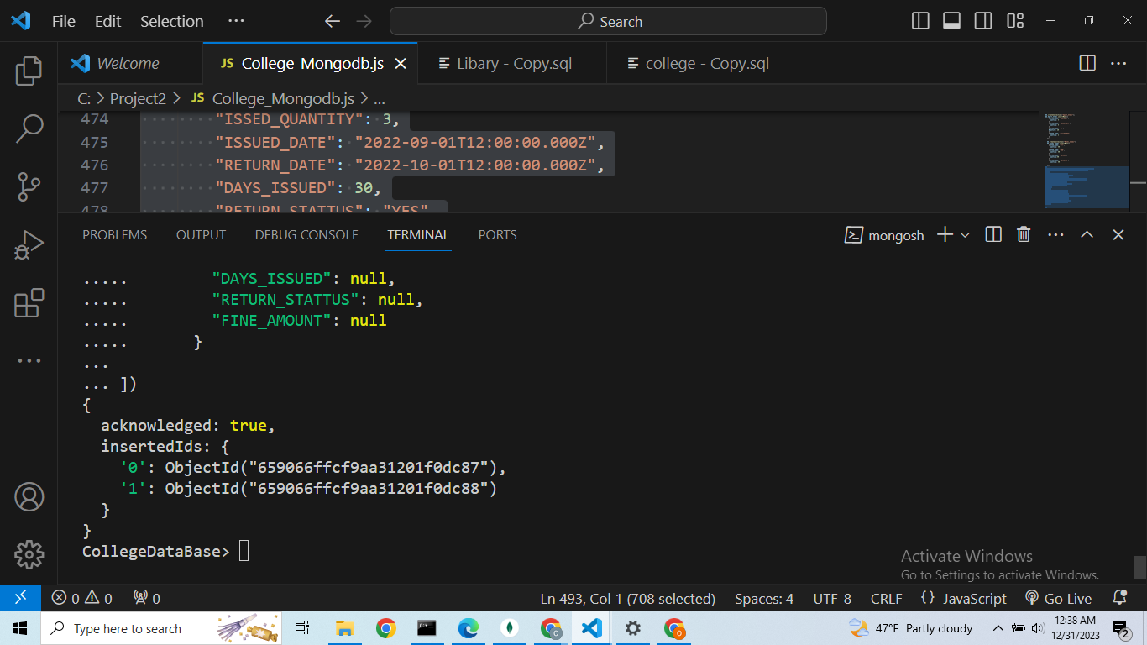**

**Descriptions:**

The NOSQL code provided operates in the MongoDB environment, primarily focusing on the "CollegeDataBase." It begins by dropping existing collections related to college information, students, teachers, staff, sport items, books, and their corresponding accounts to create a fresh database. Subsequently, collections are created and populated with sample data for college information, students, teachers, staff, sport items, and books.

Several aggregation queries are then performed. The first one involves joining student information with student accounts and sport items issued and returned. It filters students based on remaining fees and fine amounts. The second query uses the union operation to combine results from the teacher and staff collections, filtering based on remaining salary. The third query employs a nested query to find students with fine amounts in the sport items collection.

Additionally, there's a date-based query to find teachers who joined within the last year, and an OLAP feature cube aggregation for staff salaries based on gender. The provided code serves as a comprehensive example of MongoDB operations, including data manipulation and aggregation.

**Comparison of Scripts**

The comparison between Oracle SQL query and MongoDB is given below:

**TASK FOUR: JOIN**

| Query 1 -A join of three or More tables With restrictions.  The first query is a SQL join query that selects columns from three tables: Student, Student_Account,Sport_Items__Issued_and_Return_Item.It uses left join and right join operators to join the tables and a where clause to filter results.  The Second query is a MongoDB aggregation query that uses $lookup operators to perform joins between the Student,Student_Account and  Sport_Items__Issued_and_Return_Item.It includes a $match operator to filter results and a $project operator to select fields.  The goal of both queries is to retrieve information about Student, Student_Account and  Sport_Items__Issued_and_Return_Item whose remaining_fee >3000 and Fine_Amount  is greater than 50 |
| --- |

| **SQL Query** | **MongoDB Script** |
| --- | --- |
| select  Student.student_name,  Student.student_department,  Student.student_current_semester,  Student.student_address,  Student.student_contact_number,  Student_Account.remaining_fee,  Sport_Items__Issued_and_Return_Item.Issed_item,  Sport_Items__Issued_and_Return_Item.Issed_quantity,  Sport_Items__Issued_and_Return_Item.Fine_Amount  From Student  Left join Student_Account on Student.Student_id = Student_Account.student_account_id  Right join Sport_Items__Issued_and_Return_Item on Student.Student_id = Sport_Items__Issued_and_Return_Item.Issuder_id  where Student_Account.remaining_fee >3000 and Sport_Items__Issued_and_Return_Item.Fine_Amount >50; | db.Student.aggregate([  {  $lookup:{  from:'Student_Account',  localField:'student_id',  foreignField:'STUDENT_ACCOUNT_ID',  as:'stu'  }  },  {  $lookup:{  from:'Sport_Items__Issued_and_Return_Item',  localField:'student_id',  foreignField:'ISSUDER_ID',  as:'stusp'  }  },  {  $match:{  'stu.REMAINING_FEE' :{$gt:3000},  'stusp.FINE_AMOUNT' :{$gt:50}  }  },  {  $project:{  "student_id":1,  "student_name":1,  "student_department":1,  "student_current_semester":1,  "student_address":1,  "student_contact_number":1,  "stu.REMAINING_FEE":1,  "stusp.ISSED_ITEM": 1,  "stusp.ISSED_QUANTITY": 1,  "stusp.FINE_AMOUNT": 1  }  }    ]); |

**SQL output:  
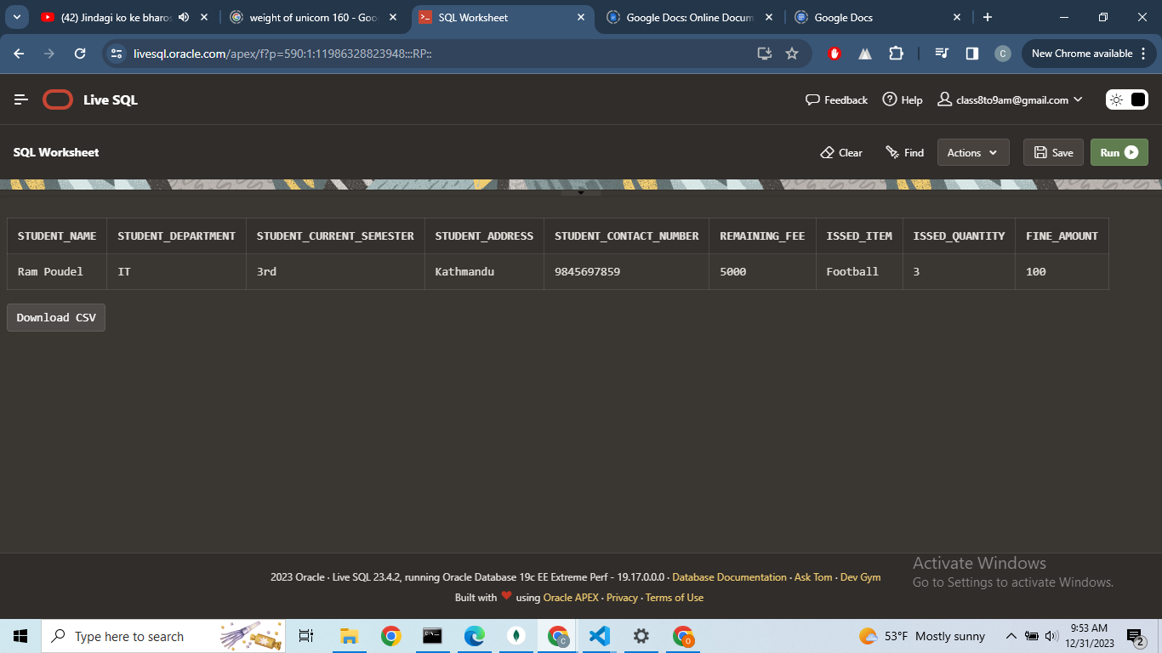**

**Mongodb Output:**

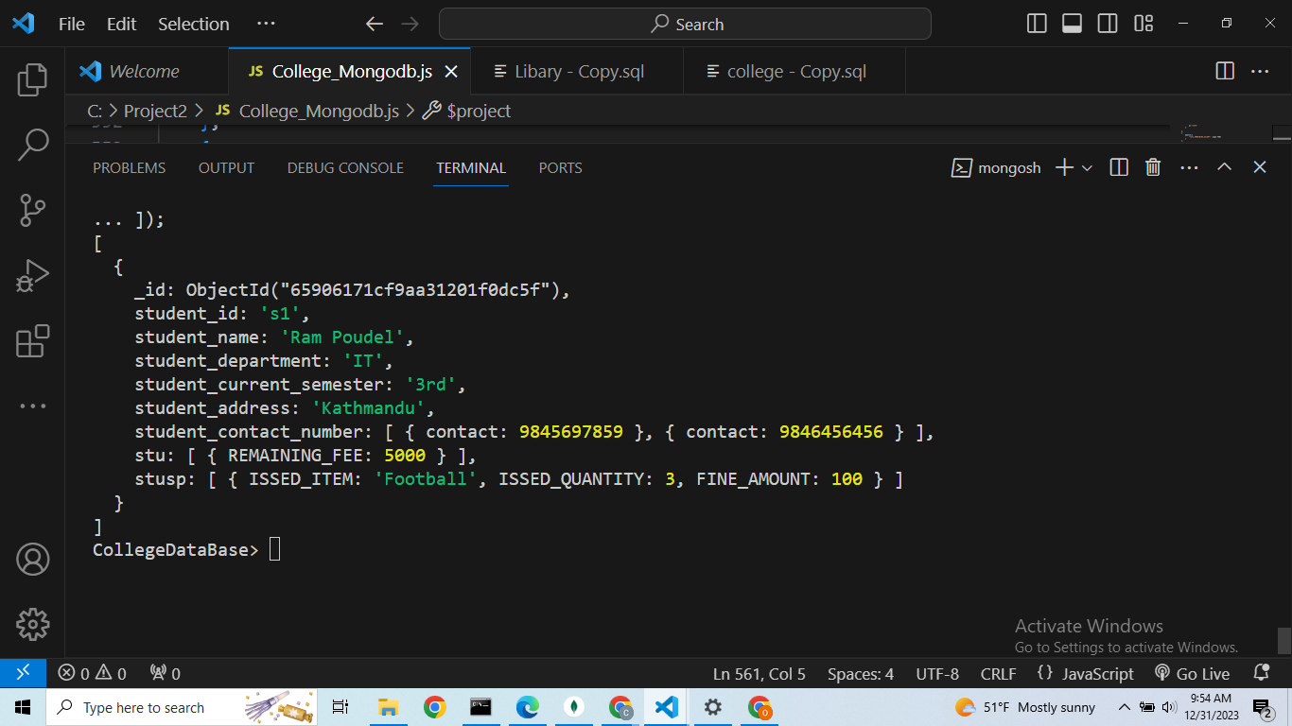

**TASK FIVE : UNION**

| Query 2: A query which uses one (or more) of UNION,DIFFERENCE or INTERSECTION  Both queries retrieve the data of Teacher,Teacher_account and Staff,Staff_account details whose remaining salary is greater than 700$ and 500$ respectively.  The first query is a SQL Union query that selects all columns from the tables Teacher and Teacher_account Union with Tables Staff and Staff_account joining them . It uses the UNION keyword to combine the results of two separate queries.  The second query is a Mongodb aggregation operation with Teacher and Teacher_Account collection along with $unionwith operator is used to join the Staff and Staff_Account collections $match operator is used to filter.Likewise $project operator is used for selection of fields. |
| --- |

| **SQL query** | **MongoDB Script** |
| --- | --- |
| select  Teacher.teacher_id,  Teacher.teacher_name,  Teacher.teacher_address,  Teacher.contact_number,  Teacher_account.remaining_salary  From Teacher  Left join Teacher_account on Teacher.teacher_id = Teacher_account.teacher_account_id  where remaining_salary >700  Union  Select  Staff.staff_id,  Staff.staff_name,  Staff.staff_address,  Staff.contact_number,  Staff_account.remaining_salary  From Staff  Right Join Staff_account on Staff.staff_id = Staff_account.staff_account_id  where Staff_account.remaining_salary > 500; | db.Teacher.aggregate([  {  $lookup:{  from:"Teacher_Account",  localField:"teacher_id",  foreignField:"TEACHER_ACCOUNT_ID",  as:"teta"  }  },  {  $match:{  "teta.REMAINING_SALARY" :{$gt:700}  }  },  {  $project:{  "teacher_id":1,  "teacher_name":1,  "teacher_address":1,  "contact_number":1,  "teta.REMAINING_SALARY":1      }    },  {  $unionWith:{  coll:"Staff",  pipeline:[  {  $lookup:{  from:"Staff_Account",  localField:"staff_id",  foreignField:"STAFF_ACCOUNT_ID",  as:"stac"  }  },  {  $match:{  "stac.REMAINING_SALARY":{$gt:500}  }  },  {  $project:{  "staff_id":1,  "staff_name":1,  "staff_address":1,  "contact_number":1,  "stac.REMAINING_SALARY":1    }  }  ]  }  }  ]) |

**SQL Output:  
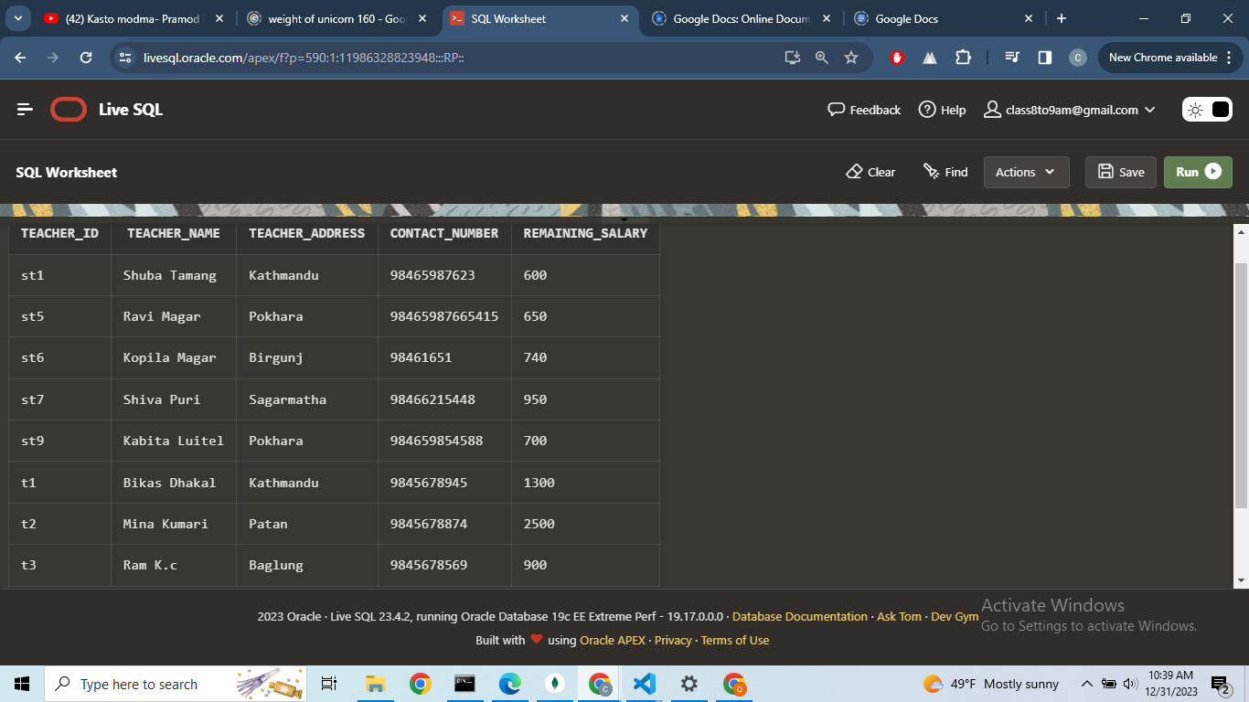  
  
  
MongoDB Output:  
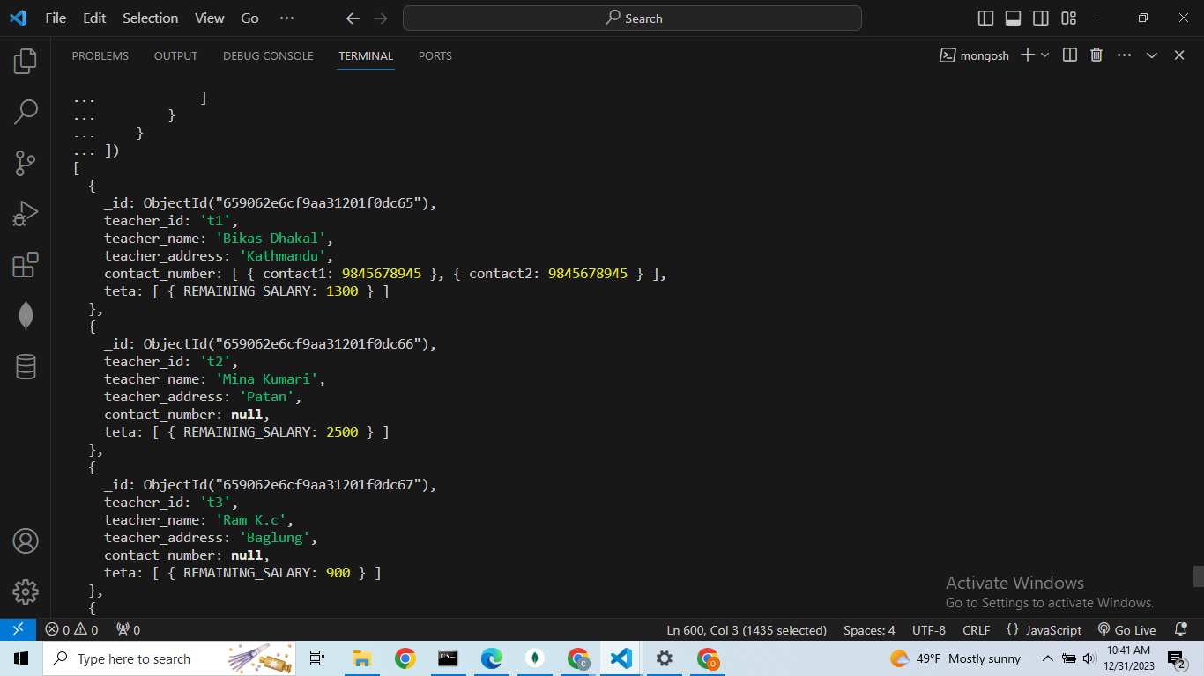**

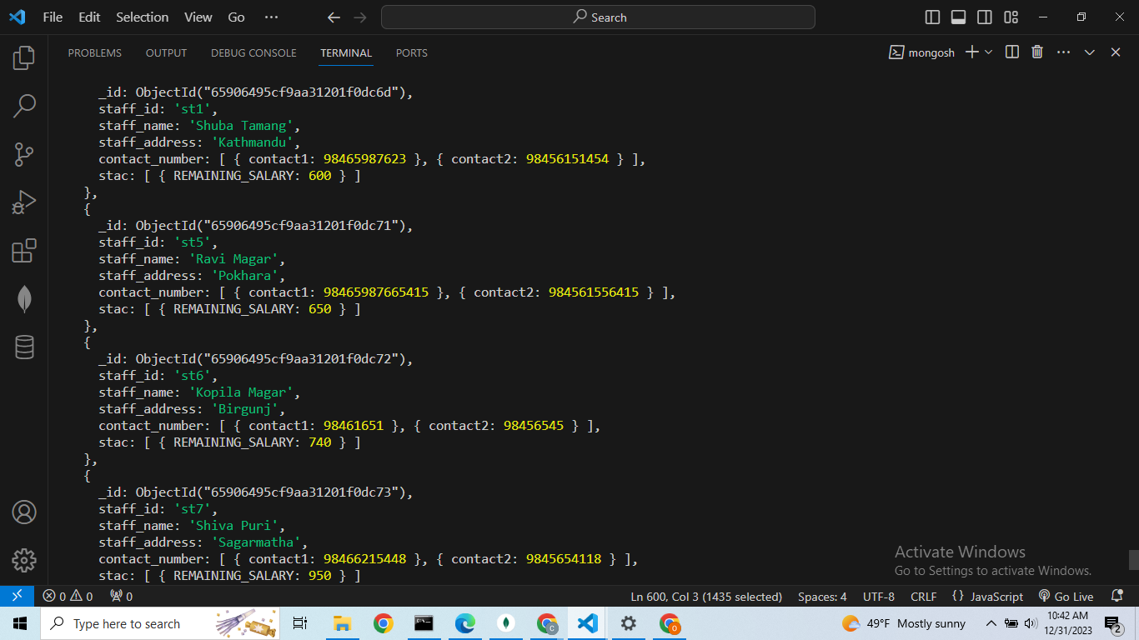

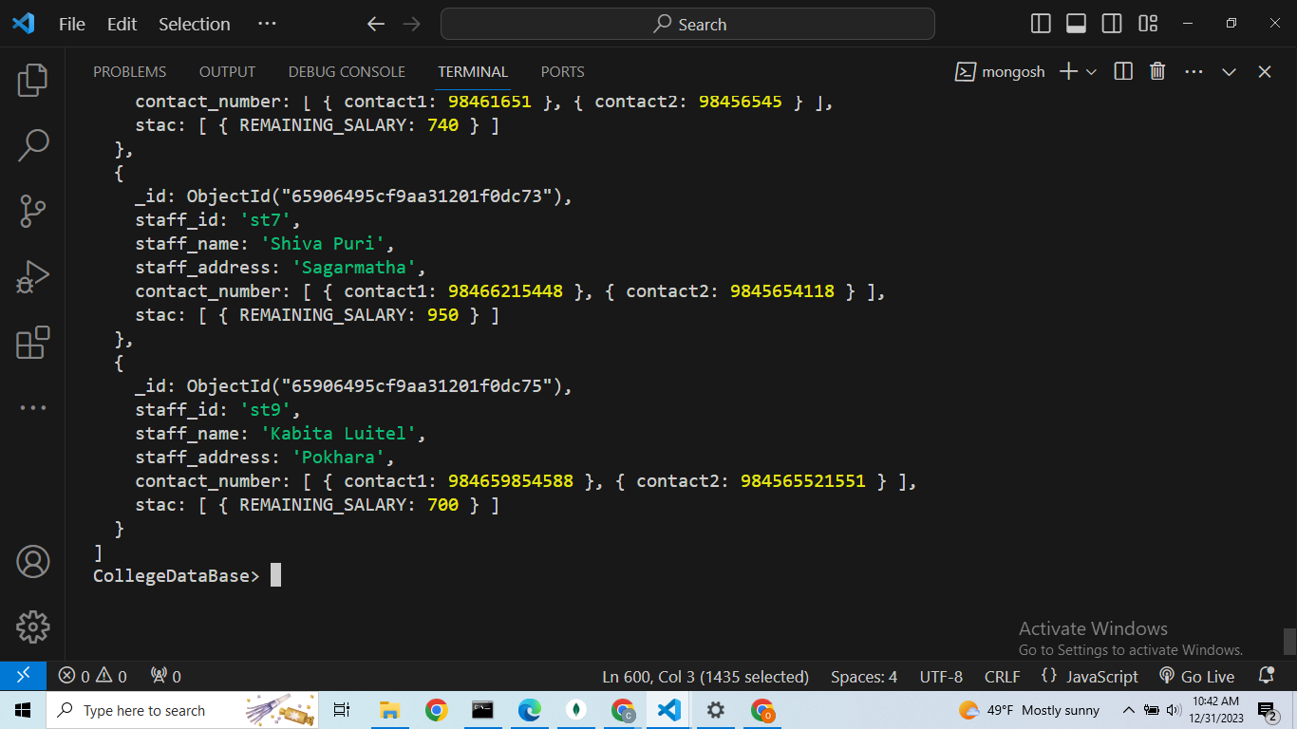

**TASK SIX : NESTED QUERIES**

| Query 3 : A query which requires use of either a nested table or subtypes .  The First query is SQL Query which select student_id,student_name, student_department,  Student_current_semester,student_address,student_contact_number from Student Table by matching student_id of this table to the Sport_Items__Issued_and_Return_Item.Issuder_id column whose Fine_Amount is greater than 50$.  The second query is Mongodb script in which two collections Student and  Sport_Items__Issued_and_Return_Itemcollection are join using $lookup ,to filter $match is used and to select the fields $project is used.  The goal of two queries is to extract the Member information which is absent in one table or collection by making the next table or collection nested . |
| --- |

| **SQL Query** | **MongoDb Script** |
| --- | --- |
| select  Student.student_id,Student.student_name,Student.student_department,  Student.student_current_semester,Student.student_address,Student.student_contact_number  from Student  Where Student.student_id In(  Select Sport_Items__Issued_and_Return_Item.Issuder_id  from Sport_Items__Issued_and_Return_Item  where Sport_Items__Issued_and_Return_Item.Fine_Amount>=50  ); | db.Student.aggregate([  {  $lookup:{  from:"Sport_Items__Issued_and_Return_Item",  localField:"student_id",  foreignField:"ISSUDER_ID",  as:"stusport"  }  },  {  $match:{  "stusport.FINE_AMOUNT":{$gte:50}  }  },  {  $project:{  student_id:1,  student_name:1,  student_department:1,  student_current_semester:1,  student_address:1,  student_contact_number:1  }  }  ]) |

**SQL Output:  
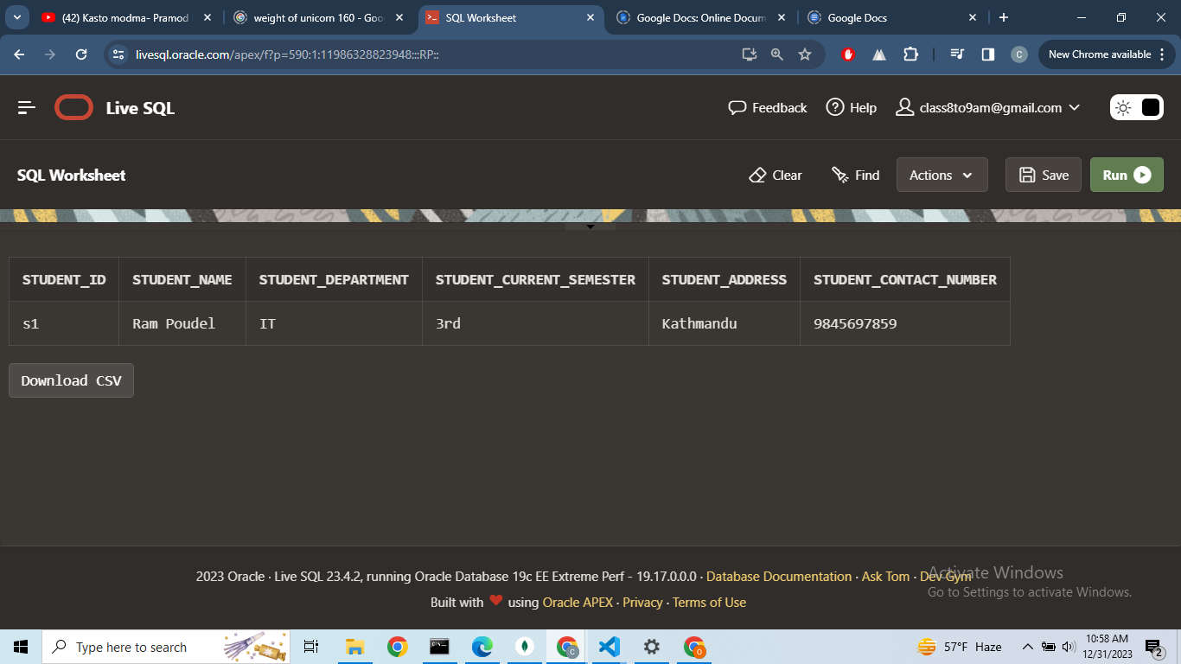**

**MongoDB Output:  
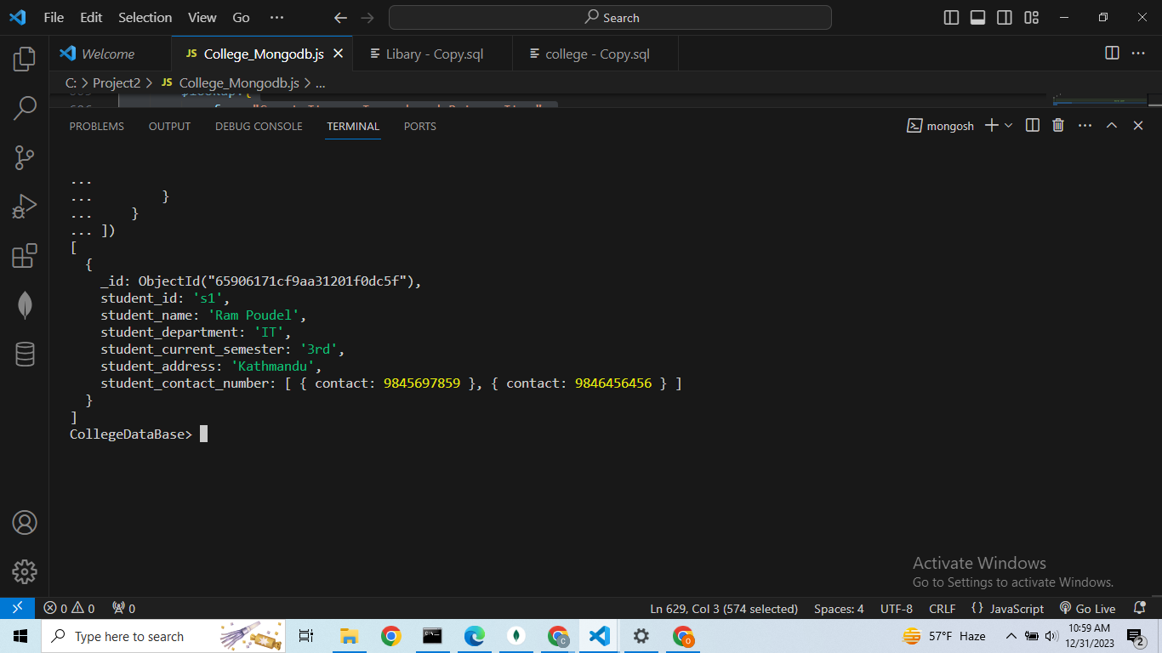  
  
TASK SEVEN : TEMPORAL FEATURE QUERY**

| Query 4 : A query using temporal features (e.g., timestamps, intervals, etc.) of Oracle SQL  The first query is SQL which uses the temporal feature Current_Timestamp.In this section this feature is used to return all teachers that were experienced of less than one year in college.  The second script is Mongodb.In this script $expr operator is used for aggregation expressions ,$and operator contains two conditions: $lte to check if ‘joined_date’ is less than or equal to one year ago from current date, $lte to check if ‘joined date’ is less than the current date Likewise, Projection is used for selecting fields. The goal of two queries is to find the Teachers who joined and have not more than one  year. |
| --- |

| **SQL Query** | **MongoDB Script** |
| --- | --- |
| SELECT  teacher_id,  teacher_name,  teacher_address,  contact_number  From  Teacher  where  join_date <= CURRENT_TIMESTAMP - INTERVAL '1' Year; | var query ={  $expr:{  $and:[  {  $lte :["$join_date",{$subtract:[new Date(),{$multiply:[365,24,60,60,1000]}]}]  },  {  $lt :["$join_date",new Date()]  }  ]  }  };  var projection ={  teacher_id:1,  teacher_name:1,  teacher_address:1,  contact_number:1  }  var result = db.Teacher.find(query,projection);  result.forEach(function (doc) {  printjson(doc);  }); |

**SQL Output:  
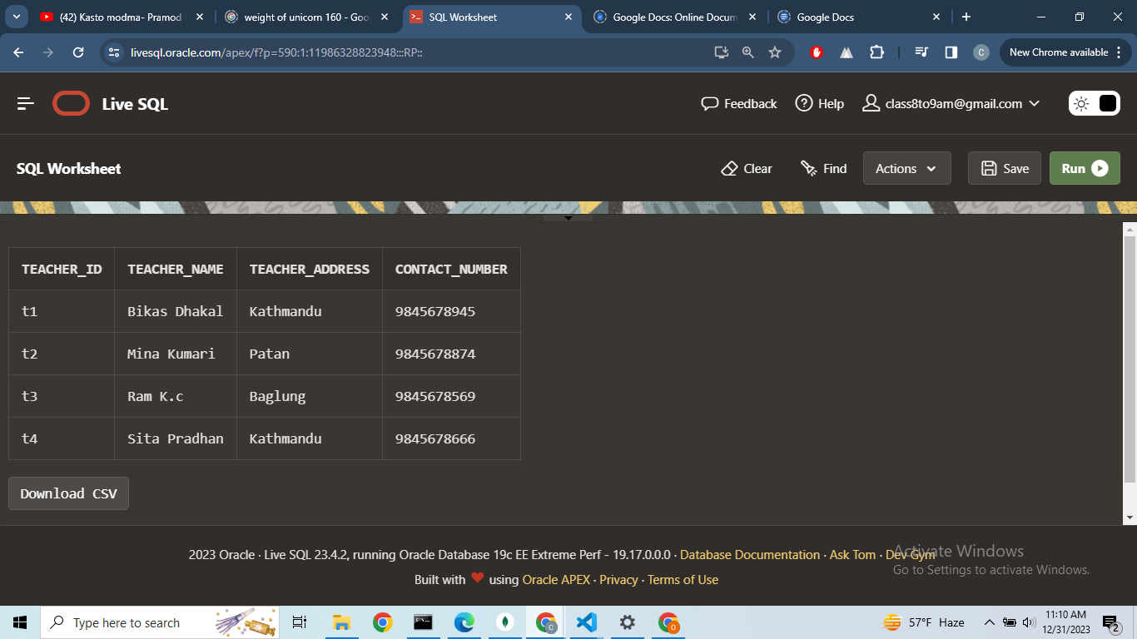**

**MongoDB Output:  
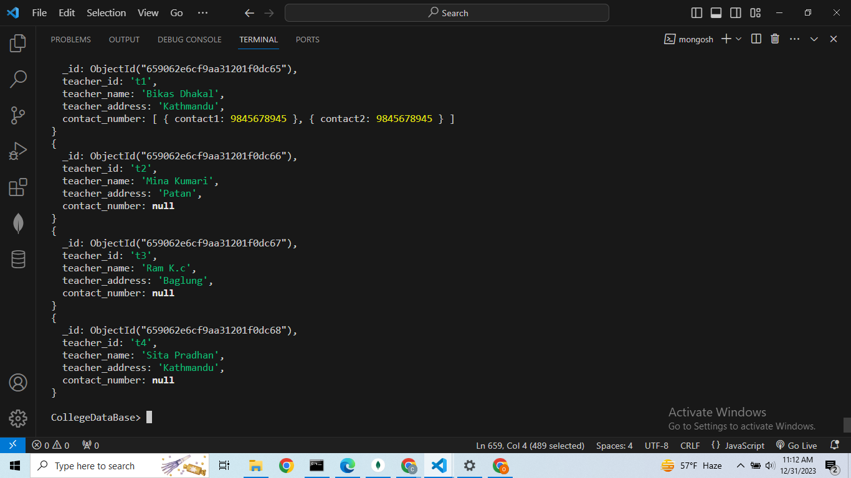**

**TASK EIGHT : TEMPORAL FEATURE QUERY**

| Query 5: A query using OLAP (e.g., ROLLUP, CUBE, PARTITION) features of Oracle SQLThe first Query is SQL which uses the Partition OLAP features.Cube feature is used to find Total_Salary using Group by the male and female gender and also find running total.  The second Query is a NOSQL query. Aggregate function is used along with $group to group by gender ,likewise $unwind,$project feature is used in a Staff_Account collection. The goal of both queries is to find total salaries based upon gender |
| --- |

| **SQL Query** | **MongoDB Script** |
| --- | --- |
| SELECT  gender,  sum(TOTAL_SALARY) as Total_Salary_sum  from Staff s  join  Staff_account sa on s.Staff_id = sa.STAFF_ACCOUNT_ID  group by  cube(Gender); | db.Staff.aggregate([  {  $lookup: {  from: "Staff_Account",  localField: "staff_id",  foreignField: "STAFF_ACCOUNT_ID",  as: "staffAccount"  }  },  {  $unwind: "$staffAccount"  },  {  $group: {  _id: "$gender",  Total_Salary_Sum: { $sum: "$staffAccount.TOTAL_SALARY" }  }  },  {  $project: {  gender: "$_id",  Total_Salary_Sum: 1,  _id: 0  }  }  ]); |

**SQL output:  
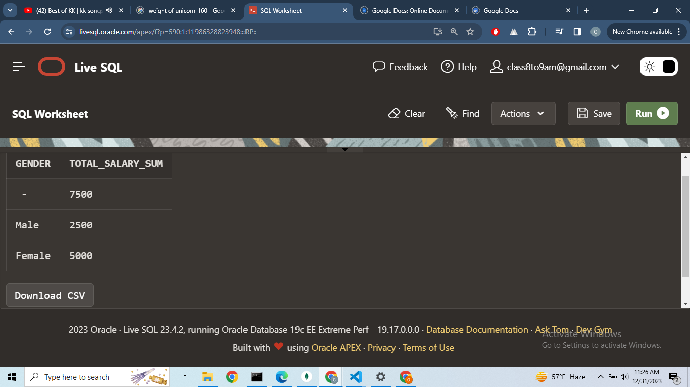**

**MongoDB Output:  
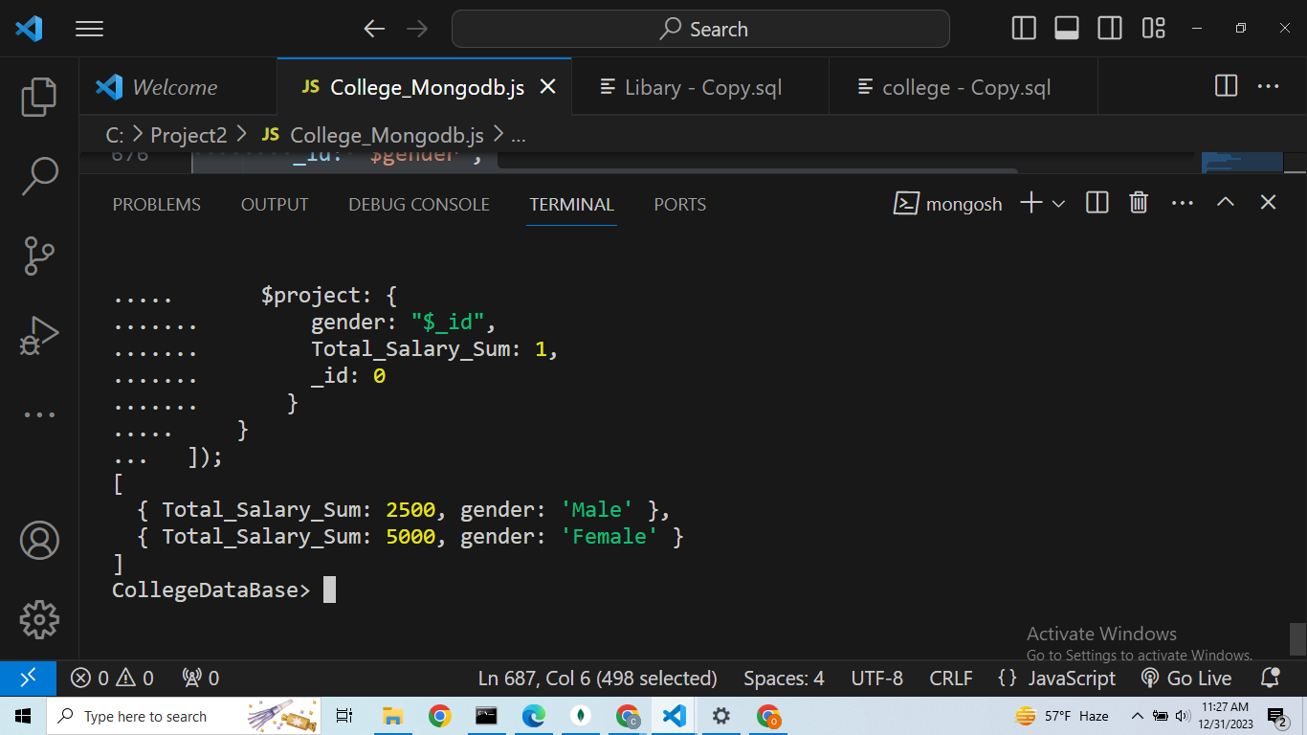**

**Conclusion:   
Conclusion:**

In conclusion, I have successfully created and run both an Oracle SQL and MongoDB database queries , and implement five queries on each to evaluate their performance.I performed queries such as joins,union,nested query,To_Timestamp, and OLAP(cube)and made sure that the result produced by both database result were similar.  
  
After evaluating the performance of both databases,I found that they were efficient and capable of handling the queries with ease.However, the choice depends upon the needs and requirements of the project.  
  
  
If a project requires structured data and adherence to ACID properties for robust transactional support, SQL databases are the preferred choice. On the contrary, in scenarios where a flexible schema and rapid development are paramount, NoSQL databases prove to be the most suitable option.

**REFERENCES:**

Author(s): Oracle Corporation

Year of publication: 2001 (you can use the last update date if available)

Title of the document: Oracle® Database PL/SQL User's Guide and Reference

URL:<https://docs.oracle.com/cd/B10500_01/appdev.920/a96624/toc.htm>

MongoDB Documentation

URL:<https://www.mongodb.com/docs/>

Boicea, A., Radulescu, F. and Agapin, L.I. (2012) “MongoDB vs oracle -- database comparison,” 2012 Third International Conference on Emerging Intelligent Data and Web Technologies [Preprint]. Available at:

https://doi.org/10.1109/eidwt.2012.32.